6COSC023W – Final Project Report



Student: Wallyson Alves Da Silva

(w1826139)

Supervisor: Francesco Tusa

School of Computer Science & Engineering

University of Westminster

Date

# Declaration

This report has been prepared based on my own work. Where other published and unpublished source materials have been used, these have been acknowledged in references.

Word Count:

Student Name:

Date of Submission:

*This is an important section!*

*Add the updated word count (do not count words in the Acknowledgments, Table of Contents, Table of Figures, Table of Tables, References, Bibliography and Appendix). Add your name and the date of submission.*

# Abstract

In present-day society, the rapid pace of life combined with demanding work schedules frequently results in a lesser connection between parents and their children. Notably, parents often endure extensive work hours or face lengthy commutes, considerably reducing the duration and quality of interactions with their children. This reduction in parental engagement can significantly impair both the emotional and cognitive development of children. Mao, Zang, and Zhang (2020) provide a comprehensive analysis of this phenomenon in their study on the effects of parental absence on child development within the Chinese context.

This project was inspired by an initial suggestion from a friend who has recently experienced becoming a father. This friend raised the need for a platform where parents can record messages or bedtime stories for children to play. This would allow his kids, and others like them, to listen to their parents’ voices and hear their stories at any time, even when the parents travel abroad or away from home for extended periods.

The name "Hikiddo" was inspired by "Aikido," a martial art known for its focus on self-defence. It blends the word "Hi," a common greeting, with "Kiddo," a friendly term for children, creating a name that sounds similar to "Aikido." This name choice is more than just a clever play with words, it reflects the app’s purpose of protecting and strengthening the bonds between family members.

The primary goal of this project is to develop "HiKiddo", an innovative mobile application designed to address the issues arising from a physical disconnection between parents and children. The app aims to strengthen familial ties by using modern technological innovations to enhance emotional bonds and support the developmental needs of children through interactive and meaningful engagements.

The "HiKiddo" application is envisioned as a space where family members can collectively participate by adding photos and videos to a shared memory board, creating meaningful voice recordings to be shared, tracking each other's location, and completing the weekly challenges, earning a reward based on points. The project will also involve conducting background research and designing and developing the application using Flutter and Firebase.

This research is designed to comprehensively assess the benefits and challenges associated with developing this project, as well as to evaluate existing tools and platforms that could be utilised. Such a detailed investigation will ensure that the platform is user-friendly, efficient, and easy to navigate. Moreover, the project will include a review phase to reflect on the outcomes and identify potential areas for improvement.

Through this project, I aim to learn the Flutter framework and Dart language, Firebase, and Google Maps Platform and expand my Mobile Full Stack developer skills. By the end of this project, my goal is to deliver a fully operational app that bridges the physical disconnection gap between parents and children, fostering significant interactions and mutual awareness that contribute to family development.

The "HiKiddo" application is not intended to substitute direct personal interactions but rather to complement them by enhancing familial relationships and supporting pivotal developmental milestones in the lives of children. Since we are living in a technologically driven era, I aim to harness its power to enrich the bond between families. By concentrating on user-friendly access, emotional bonding, memory conservation, and educational tasks, the application aims to alleviate the adverse effects of parental absence and build family well-being. Ultimately, the "HiKiddo" app endeavours to address the contemporary challenges of familial connectivity by offering a robust platform that aids families in nurturing stronger bonds, irrespective of geographical distances.

# Acknowledgements

As I approach the conclusion of my academic journey, I am overwhelmed with gratitude and sense of accomplishment. This milestone would not have been possible without the support and encouragement from some important people in my life.

Above all, I am thankful to my fiancée, Catarina Vieira. Her motivation and faith in my abilities inspired me to pursue higher education. Her constant support has been my foundation over these past three years, and shaping the concept and design of the "HiKiddo" app. Her presence has been a continual source of comfort and inspiration, and I am extremely grateful to have her by my side.

I would also like to extend my gratitude to my supervisor, Francesco Tusa, whose guidance and insights have been essential. His mentorship has not only helped refine my skills but also deepened my approach to research and development.

Additionally, I am equally grateful to my colleagues, Mohammed Mohammed, Mubashar Khan, and Diogo Sousa. Their thoughtful feedback, engaging discussions, and cooperative spirit throughout these years have significantly contributed to the success of this project.

Each of these individuals has had a profound impact on my personal and professional growth, and I am eternally grateful for their contributions. Thank you for being part of my journey – your support has made all the difference.

# Table of contents

Declaration 2

Abstract 3

Acknowledgements 5

Table of contents 6

List of figures 8

List of tables 9

1. Introduction 10

1.1 Problem statement 10

1.2 Aims and Objectives 11

Develop an Intuitive User Interface 11

Implement Voice Recording Feature 11

Create a Memory Board 11

Establish a Task and Rewards System 11

Ensure Security and Privacy 12

2. Background 13

2.1 Literature survey 13

2.2 Review of projects / applications 15

Remento 15

Life360 17

FamilyAlbum 18

2.3 Review of tools, frameworks and techniques 22

Flutter (Mobile Development Framework by Google) 22

React Native 23

Kotlin 24

Swift 25

PostgreSQL 27

MySQL 28

Firebase (Backend Platform by Google) 29

3. Legal, social and ethical issues 31

Legal Considerations 31

Ethical Considerations 31

Social Considerations 31

Professional Considerations 31

Security Considerations 31

Integration with Firebase 31

4. Methodology 32

Design 32

Development and testing 33

Gantt Chart 36

5. Design 37

Data flow diagram 37

User Interface 38

Welcome, Login & Sign-up pages 38

Email Verification & Join Family group pages 39

Dashboard/Home page 40

Sidebar Menu, About & Contact Us sheet 41

Profile & Location pages 42

Family Memories Page (Memory board) 43

Family group page 44

Sequence Diagram 46

6. Tools and implementation 48

6.1 Tools 48

Flutter & Dart 48

Firebase 48

Google Maps Platform 49

Dart and Flutter packages used: 49

New Skills Developed 50

6.2 Implementation 51

Project Folders Structure 54

Code Implementation 55

7.1 Test coverage 68

7.2 Test methodology 73

8. Conclusions and reflections 74

9. References 76

Appendix I 79

# List of figures

Figure 1 - Remento 16

Figure 2 - Life360 18

Figure 3- FamilyAlbum 19

Figure 4 - Gantt Chart 36

Figure 5 - Data flow diagram 37

Figure 6 - Welcome, Login and Sign-up Page 38

Figure 7 - Email verification and Join Family group Page 39

Figure 8 - Join Family group Process 39

Figure 9 - Home Page 40

Figure 10 - Sidebar Menu, About and Contact Us sheet 41

Figure 11 - Profile and Map view pages 42

Figure 12 - Family Memories Page 43

Figure 13 - Family group Badger when there is a new request to join 44

Figure 14 - Family Group Page 44

Figure 15 - Challenges Page, From Host View 44

Figure 16 - Storyteller Page (Voice recording feature) 45

Figure 17 - Sequence Diagram 46

Figure 18 - Firebase Build 50

Figure 19 - Firestore Data structure 51

Figure 20 - Firebase connection with the project 52

Figure 21 - Project folder structure 53

Figure 22 - main.dart 54

Figure 23 - Method to Register User 54

Figure 24 - Sign-up Button on press function 55

Figure 25 - Login method 55

Figure 26 - Join Family method 56

Figure 27 - Profile Load and Save image functions 57

Figure 28 - Capture photo and video or choose from the gallery method 59

Figure 29 - Initialise voice record, delete record method and delete confirmation dialog methods 60

Figure 30 - Voice recording model to retrieve data from Firebase 61

Figure 31 - Save voice recording method 62

Figure 32 - Widget build 62

Figure 33 - StreamBuilder 62

Figure 34 - Google Maps widget 63

Figure 35- Request location services permission method 64

Figure 36 - Location and Markers update method 65

Figure 37 - Marker icon method 66

# List of tables

*Provide a list of tables (if any), linking table numbers to page numbers. If you can, hyperlink the page numbers/tables*.

Table 1 - Features Comparation 20

Table 2 – Black box testing 66

# 1. Introduction

## 1.1 Problem statement

In today's fast-paced world, the increased demands of modern jobs, including long work hours, frequent travel, and relocations, can significantly challenge the connections between parents and their children, often reducing the precious time families have to spend together. This lack of physical and emotional closeness can really weaken family bonds.

Studies like the one by Mao, Zang, and Zhang (2020) in their paper "The Effects of Parental Absence on Children Development: Evidence from Left-Behind in China" show the tough impacts this separation can have. Their research points out that kids who don't see their parents enough might develop more slowly in terms of their thinking abilities and emotional health. This can lead to worse grades in school and low self-confidence, problems that might follow them into their adult lives and affect their careers and personal relationships.

However, with almost everyone having smartphones and access to the internet these days, we have a big chance to use technology to soften some of these negative effects. The "HiKiddo" app is a creative solution designed to close the emotional distance between parents and their children. It offers a way for family members, even if they're far apart, to connect deeply and meaningfully.

The need for an app like "HiKiddo" becomes obvious when we look at how modern family life is shaped and the pressures that come from today's work demands. By offering a way to keep and boost the emotional ties between parents and children, "HiKiddo" seeks to enhance the well-being of families who are trying to cope with being apart physically.

In conclusion, "HiKiddo" addresses the need for a technological solution to the growing problem of family disconnection in today's digital world. The app includes features that encourage sharing special moments through photos, videos, voice recordings and weekly challenges that can be used for educational purposes. Not only does it support the development of children who may not always be physically near their parents, but it also strengthens the essential family bonds and fosters a sentiment of care.

## 1.2 Aims and Objectives

The main aim of the "HiKiddo" mobile app is to address the emotional and developmental challenges that arise from the physical distance between parents and children, often due to modern work requirements. By using advanced mobile technology, the app works to strengthen emotional connections within families, helping children feel closer to their parents even when they're apart.

Additionally, I aim to create a simple and enjoyable mobile application that is accessible to users of all ages. With "HiKiddo," parents will be able to foster greater awareness of their children's development and the importance of parental connection.

To fulfil this aim, the development of "HiKiddo" will follow several targeted objectives:

### **Develop an Intuitive User Interface**

Craft a user-friendly interface that both children and adults can easily navigate. This will include straightforward, accessible pathways to the app's various features, like the storyteller (voice recording feature), the memory board, the task and rewards system, and the location map. The interface will also be designed to be visually attractive to draw in users and promote consistent use.

### **Implement Voice Recording Feature**

Incorporate features such as voice recording and real-time sharing to enable parents to leave voice messages, bedtime stories, and personal notes that children can access anytime.

### **Create a Memory Board**

Build a feature that allows families to upload and securely store photos and videos of any important family memento. This feature will serve as a collective space for family members to relive beloved memories and stay connected to their shared past.

### **Establish a Task and Rewards System**

Set up a system where parents can assign tasks to their children, including educational assignments or household duties. Children will earn points for completing these tasks, which can then be traded for rewards. This system aims to create a sense of responsibility and motivate children while also making daily tasks more enjoyable while learning soft life skills.

### **Ensure Security and Privacy**

Apply strict, safe coding methods to ensure the safety and privacy of all users. Measures will include secure login processes, encrypted data storage, verifying user's access through the system, making sure they only have access to the information related to their family group, and ensuring that families can use the app with confidence.

Through these specific objectives, "HiKiddo" aims to provide a comprehensive tool that not only enhances emotional well-being and strengthens family ties but also supports the cognitive and social development of children in a fun and interactive way.

# 2. Background

## 2.1 Literature survey

In today's busy world, many parents have to work long hours, travel often, or even live temporarily far from home. This can really change the way families interact, especially the crucial bond between parents and children. Let's dive into what this means for kids and how families might cope better with these challenges.

Imagine a parent missing their child's first steps or other big moments because they're away for work. About 46% of parents worry about this very thing, feeling they might miss important parts of their child's growing up (Employer News, 2020). When parents aren't around as much, kids might feel less connected to them, which can affect how they behave and feel.

Researchers like Elbitar (2020) found that not spending enough face-to-face time with parents can make kids feel emotionally distant. This isn't just about feeling sad or left out—kids might actually act out or have a hard time dealing with their emotions.

It's not easy for anyone when families can't be together. Studies suggest that kids might feel more anxious or even depressed when they don't see their parents often (Holleron, 2020). And parents? They feel guilty and stressed about not being there. It's a tough situation that can make everyone feel worse, creating a cycle of stress and upset feelings.

Early research suggests that digital tools can help families stay connected and can really make a difference in kids' emotional and mental well-being. These digital options can give kids the regular contact with their parents they need to grow up happy and healthy.

The concept of "technoference" (McDaniel & Radesky, 2018) highlights how technology can sometimes disrupt personal interactions but also enhance them when used thoughtfully. For family dynamics, apps can create new ways for family members to connect effectively despite physical separation, strengthening family bonds across distances.

So, what can we do about it? Well, technology might help bridge the gap. Apps like "HiKiddo" offer cool features like digital storytelling and interactive tasks that can help parents and kids feel closer, even if they're not physically together. By sharing moments and daily updates, they can keep the parent-child bond strong.

The "HiKiddo" app is designed with features to enhance family connections:

Interactive Challenges and Rewards - Children can complete parent-set tasks to earn rewards. This encourages not only ongoing communication but also promotes learning and discipline in a fun way.

Voice Recording - Parents can record voice messages or their voices reading a story, creating a sense of presence as they record a story or an important message for their kids, showing that they are there for them and helping to close the emotional gap caused by physical distance.

Memory board - A secure place for families to upload and save photos and videos, accessible anywhere, fostering a shared family album.

Additionally, the "HiKiddo" app includes a location tracking feature that allows family members to see each other’s whereabouts. This function aims to enhance safety and peace of mind by keeping family members connected not just emotionally and digitally but also physically by knowing each other's location.

Creating a family-oriented mobile app comes with significant challenges. Key concerns include ensuring privacy and security due to the sensitive data, like photo uploads and location tracking. Moreover, the app must be accessible to all ages, requiring careful design to make sure it's easy for young children to use. This involves detailed testing and user interface adjustments to accommodate inexperienced users.

In conclusion, research shows children's challenges when separated from their parents, but technology like the "HiKiddo" app can bridge the gap, ensuring continuous love and communication. This app not only supports children’s emotional health but also provides parents with the necessary tools to maintain strong connections, irrespective of their busy schedules. By integrating these features effectively, "HiKiddo" has the potential to greatly enhance parental involvement and redefine digital interactions within families, keeping family ties strong, even from afar.

## 2.2 Review of projects / applications

Exploring existing applications is crucial in software development, providing developers with essential insights and a deep understanding of the market. Through comprehensive analysis of successful family-oriented applications, developers can identify best practices, discover innovative features, and avoid potential pitfalls. This proactive approach is detailed in the next section, which examines three real-world applications that exemplify these strategies, helping to shape the development of new projects like the "HiKiddo" app.

The concept for the "HiKiddo" app was sparked by both a personal story and a clear need for more family-oriented mobile applications. The development process included a detailed analysis of existing apps such as Remento, Life360, and FamilyAlbum, which vary in their offerings from location tracking to photo sharing. This exploration helped identify key features that could enhance family connectivity. It guided the refinement of "HiKiddo" to ensure it offers unique and valuable functions that are not fully addressed by current market options.

### **Remento**



Figure 1 - Remento

Remento is an innovative online platform that helps users preserve and share significant memories using media such as photos, videos, and audio clips. As physical albums and journals become less common, Remento offers a digital solution to capture and catalogue personal stories easily.

One standout feature of Remento is its "speech-to-story" function, which turns voice recordings into text. This tool makes it easier to preserve spoken memories as written narratives. Although the platform is user-friendly, its aesthetic, characterised by dark green tones, tends to be more adult-oriented and might not attract a younger audience.

**Influence on HiKiddo App Development**

Inspired by Remento's capabilities, including a section for photos and videos will be crucial for the HiKiddo mobile app. The "speech-to-story" feature, particularly, has caught my attention as a potential addition to HiKiddo. Implementing a similar feature could enhance the storytelling experience within the app, making it more engaging for users to create and share their narratives. However, introducing this feature is not currently a primary focus for immediate development in HiKiddo but remains a consideration for future updates.

**Functionality and Design Considerations:**

Functionality: Remento primarily supports the saving and sharing memories through various media, enriching users' storytelling experiences.

Unique Feature: The innovative "speech-to-story" technology transforms voice recordings into text.

Pros: This feature simplifies the process of capturing and sharing stories, making it more accessible to users who prefer text over audio.

Cons: The app's design, with its mature colour palette, may not appeal to all age groups, particularly younger children.

Influence on HiKiddo: The structure of Remento has inspired integrating multimedia memory sections in HiKiddo and highlighted the potential for adopting a similar speech-to-text feature in the future.

This analysis underscores the importance of Remento as a source of inspiration for enhancing the HiKiddo app's capabilities and creating a more interactive and memorable user experience.

### **Life360**

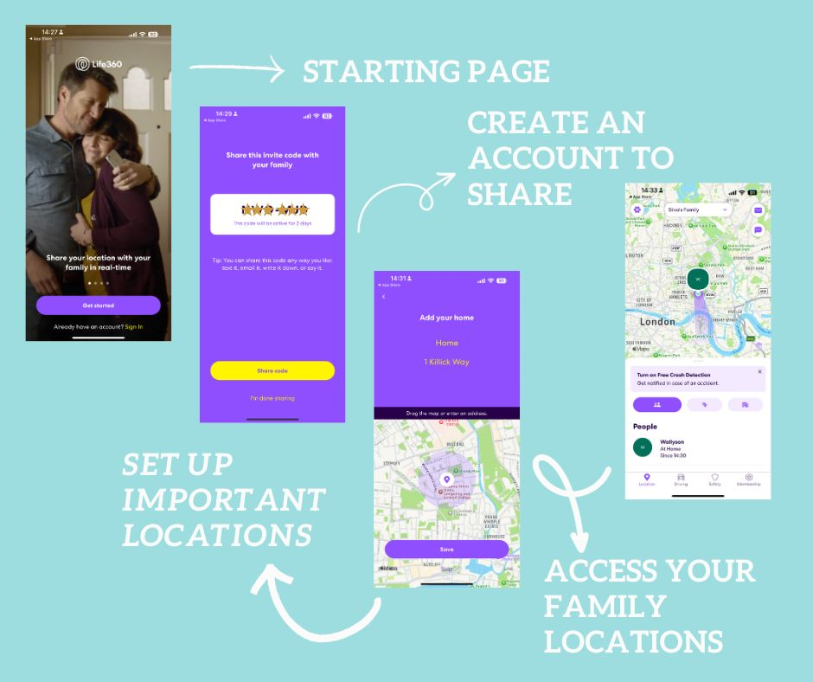

Figure 2 - Life360

Life360 is distinguished by its strong focus on family safety through its digital and location-based features, making it highly pertinent to developing the HiKiddo app. Life360 provides advanced features like real-time location tracking and a unique crash detection system, which are essential for ensuring the safety of family members.

For HiKiddo, incorporating a similar location-based feature is a key focus, allowing parents to effectively monitor their children's whereabouts to ensure their safety. Additionally, Life360's user-friendly interface and comprehensive tutorial guide offer excellent frameworks for designing an intuitive and straightforward user interface for HiKiddo. The visually appealing design elements like colour schemes and animations used in Life360 are also inspirations for HiKiddo to maintain user engagement and ensure a pleasant user experience.

**Functionality and User Interface Design:**

Functionality: Life360 has features that prioritise family safety, including real-time location tracking and a sophisticated crash detection system.

Pros: The application is known for its user-friendly interface that includes helpful tutorial guides and its attractive design characterised by vibrant colours and dynamic animations.

Cons: The app's focus is predominantly on safety features, which may come at the expense of fostering everyday family interactions and bonding.

Influence on HiKiddo: Life360 has significantly influenced HiKiddo's user interface design choices. It has guided the inclusion of similar digital location tracking features, which are tailored to enhance family safety within the HiKiddo environment.

This comprehensive evaluation of Life360's capabilities highlights how its features and design can enhance the HiKiddo app. By incorporating Life360's robust safety tools and user-friendly interface into HiKiddo, the app not only aims to ensure child safety but also to offer an engaging and easy-to-navigate experience for all family members.

### **FamilyAlbum**

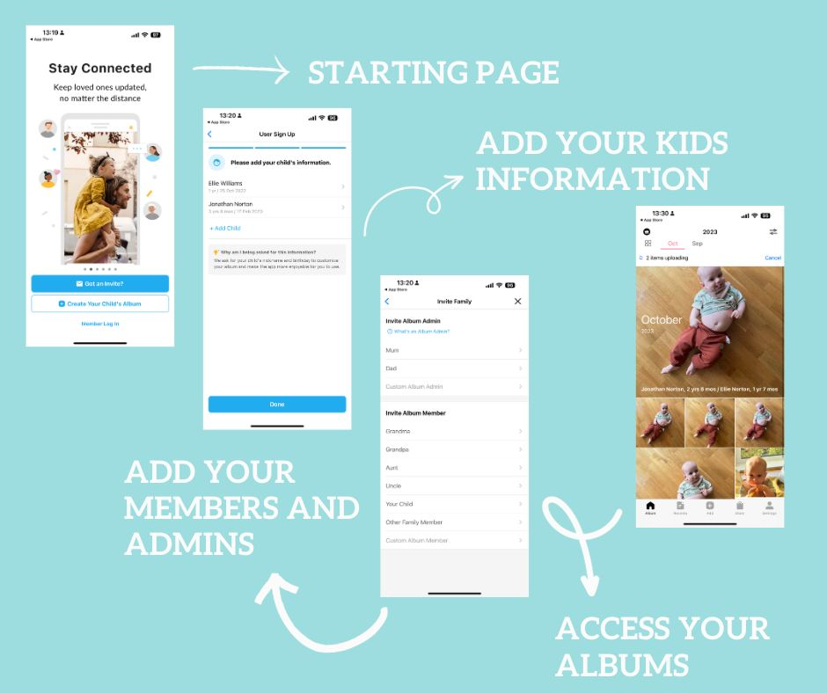

Figure 3- FamilyAlbum

FamilyAlbum, developed by Kenji Kasashara, is a mobile app designed to make it easy for families to organise and share photos and videos from significant events securely. The app emphasises simplicity and security, allowing users to keep cherished family moments safe while sharing them with loved ones.

While FamilyAlbum features a clean and straightforward design, its user interface has some complexities that could be challenging for certain age groups. Introducing a tutorial guide could significantly enhance accessibility, helping users of all ages to navigate and use the app more effectively.

FamilyAlbum's core mission to make the sharing and organising of family memories straightforward has significantly shaped the HiKiddo app. Drawing inspiration from this, HiKiddo incorporates similar functionalities, allowing users to easily add photos and videos, which ensures that these cherished moments are both secure and readily sharable.

Functionality: FamilyAlbum provides a user-friendly platform for families to store, share, and manage photos and videos, ensuring these memories are kept safe and organised.

Pros: The application offers robust security features that protect personal and sensitive data, making it a trustworthy repository for family memories.

Cons: The interface, while clean, maybe slightly complicated for some users, particularly younger or older family members who are not as tech-savvy; it also lacks features that facilitate interactive engagement.

Influence on HiKiddo: Inspired by FamilyAlbum, the HiKiddo app will feature a "memory board" where users can upload photos and videos or even capture moments in real-time using the camera. This addition aims to enrich the user experience by making the sharing and preservation of family memories more dynamic and interactive.

This analysis highlights the strengths of FamilyAlbum's approach to family memory sharing while identifying areas for enhancement. HiKiddo can build on these insights to offer a more comprehensive and engaging platform that improves family connectivity, addressing the gaps found in FamilyAlbum's current setup.

To better illustrate the distinctions and inspirations drawn from these applications, a Table of Features was created:

This table shows how "HiKiddo" incorporates and expands upon the best features of these apps.

Table 1 - Features Comparation

|  |  |  |  |  |
| --- | --- | --- | --- | --- |
| Features | Remento | FamilyAlbum | Life360 | Hikiddo |
| Login/Sign up | Tick with solid fill | Tick with solid fill | Tick with solid fill | Tick with solid fill |
| User Friendly to all ages | Close with solid fill | Close with solid fill | Close with solid fill | Tick with solid fill |
| Join a family group | Close with solid fill | Close with solid fill | Tick with solid fill | Tick with solid fill |
| Add photos and videos in a shared space | Close with solid fill | Close with solid fill | Close with solid fill | Tick with solid fill |
| Shared voice recording | Close with solid fill | Close with solid fill | Close with solid fill | Tick with solid fill |
| Speech-to-text | Tick with solid fill | Close with solid fill | Close with solid fill | Close with solid fill |
| Family comments to photos & videos | Close with solid fill | Tick with solid fill | Close with solid fill | Close with solid fill |
| Generate a compilation of moments with photos and videos | Close with solid fill | Tick with solid fill | Close with solid fill | Close with solid fill |
| Challenges and rewards section shared with the family group | Close with solid fill | Close with solid fill | Close with solid fill | Tick with solid fill |
| Tasks that can be used for educational purpose | Close with solid fill | Close with solid fill | Close with solid fill | Tick with solid fill |
| Share current location | Close with solid fill | Close with solid fill | Tick with solid fill | Tick with solid fill |
| Retrace members location | Close with solid fill | Close with solid fill | Tick with solid fill | Close with solid fill |
| Emergency SOS button | Close with solid fill | Close with solid fill | Tick with solid fill | Close with solid fill |
| Paid subscription needed | Tick with solid fill | Close with solid fill | Tick with solid fill | Close with solid fill |

"HiKiddo" stands out from other apps because it really focuses on helping families stay connected in a fun and safe way. It has featured such the memory board that lets you keep all your special memories in one place, but it's even more than that. The app also motivates family members to keep in touch and do activities together every week, whether through sending little voice recording or completing fun tasks together. Plus, it's designed to be super easy to use, so everyone from kids to grandparents can get the hang of it quickly.

A potential disadvantage could be the complexity of offering multiple features in one app, which might overwhelm new users. However, this is mitigated by the planned tutorial guides and intuitive design inspired by Life360.

The background research into existing family-oriented applications provided crucial insights that shaped the development of "HiKiddo." By analysing the strengths and weaknesses of these apps, "HiKiddo" was designed to offer a comprehensive and engaging platform that not only ensures safety but also promotes active family engagement, filling a unique niche in the app market.

## 2.3 Review of tools, frameworks and techniques

Choosing the right tools, frameworks, and techniques is crucial in mobile app development, as these decisions greatly affect how the project turns out in terms of efficiency, quality, upkeep, and how well it can grow in the future.

This section offers a detailed review of the pros and cons of different programming languages and development tools, including Flutter, Kotlin, React Native, Swift, PostgreSQL, Firebase, and MySQL. We will thoroughly explore each technology to highlight its main advantages and limitations, providing clear insights to assist in selecting the best technologies for developing the “HiKiddo” app.

### **Flutter (Mobile Development Framework by Google)**

Flutter is an open-source UI software development kit developed by Google. It allows developers to build high-quality applications for mobile, web, and desktop from a single codebase. As a contemporary toolkit, Flutter enables the creation of visually striking applications that compile directly to native code on various devices and operating systems. Supporting multiple platforms such as Android, iOS, Linux, macOS, and Windows, Flutter offers a flexible and versatile option for developers looking to create cross-platform apps.

Advantages:

1. Single Codebase: Use one codebase for both platforms, making development simpler and cheaper.
2. Hot Reload: See changes instantly without restarting the app, speeding up development.
3. Performance: Compiles into native code for fast, smooth device performance.
4. UI Capabilities: Lots of customisable widgets to create attractive, easy-to-use interfaces.
5. Growing Community: A rapidly expanding community provides great support and resources for developers.

Disadvantages:

1. Large App Size: Flutter can create larger app files, which might slow down download times and use more data, which is not ideal for making lightweight apps.
2. Developing Ecosystem: As a newer technology, Flutter doesn't have as many third-party resources or libraries yet, which might limit your options and extend development time.
3. Learning Curve: Flutter uses Dart, a less common programming language than JavaScript, which might take some time to learn if you're new to it.

### **React Native**

React Native is a free-to-use framework that lets you create cross-platform mobile apps for Android and iOS using JavaScript and React, a JavaScript library for making user interfaces that Facebook and Instagram developed alongside a global community of developers. This framework utilises JSX, which combines JavaScript with HTML-like syntax, to help developers write richer app interfaces and enable smooth cross-platform mobile applications that feel truly native.

Advantages:

1. Declarative Programming Model: Makes code easy to read and debug by clearly showing how data changes, helping you quickly solve problems.
2. Component-Based Architecture: Organizes code into reusable pieces for a cleaner codebase and simpler development, ideal for ongoing projects and future maintenance.
3. Virtual DOM: Speeds up app rendering for a smoother user experience by minimising direct changes to the DOM.
4. Community Support: Offers a strong network with access to numerous resources like libraries and expert advice, which can be incredibly helpful in overcoming challenges and learning new skills.
5. Integration Capabilities: Provides the flexibility to use various libraries and frameworks, enhancing creativity and adaptability in app development.

Disadvantages:

1. Learning Curve: JSX and complex JavaScript concepts might be difficult for beginners, potentially steepening the initial learning phase.
2. Optimisation: Poorly optimised code can slow down the app, necessitating careful coding to ensure smooth performance.
3. Memory Management: Apps with many features may have large file sizes, leading to longer loading times, particularly on slow internet connections.
4. Setup Complexity: Setting up modern development tools can be complex and time-consuming, possibly overwhelming for those new to programming.

### **Kotlin**

Kotlin is a programming language that Google officially endorsed in 2017 as the preferred language for Android app development. It’s open-source and compiles to Java bytecode, allowing it to run on the Java Virtual Machine (JVM). Kotlin integrates functional programming features with object-oriented principles, making it a flexible and modern choice for developers who want to create Android apps or other types of applications that operate on the JVM.

Advantages

1. Full Interoperability with Java: Kotlin is fully compatible with Java, allowing both languages to be used seamlessly in the same project. This helps teams smoothly transition from Java to Kotlin or maintain both on ongoing projects.
2. Concise and Expressive Language: Kotlin reduces unnecessary code, making it clearer and easier to manage. This leads to fewer bugs and easier debugging.
3. Enhanced Type Safety: Kotlin's approach to nullability reduces the risk of null pointer exceptions, a common issue in Java, enhancing application stability.
4. Support for Functional Programming: Kotlin supports functional programming features like lambdas and higher-order functions, enabling cleaner and more expressive code.
5. Advanced Concurrency with Coroutines: Kotlin’s Coroutines simplify handling long-running tasks and asynchronous programming, improving code manageability and performance without blocking the main thread.

Disadvantages

1. Learning Curve: Even though Kotlin works well with Java, Java developers might need time to adjust to the different syntax and advanced features.
2. Tooling Support: Kotlin has good tools, but they may not be as extensive or advanced as Java's due to its longer establishment period. This could make finding specialised tools or troubleshooting more difficult for Kotlin developers.
3. Compilation Time: Kotlin usually has slower compilation times compared to Java, which could be a setback in large projects that need frequent compilation, potentially affecting productivity.
4. Developing Ecosystem: The Kotlin ecosystem is expanding but isn't as developed as Java's. This means there are fewer third-party libraries, and those available might not be as robust, limiting resources for developers.
5. Performance Issues: Kotlin might face performance and compatibility issues, particularly with complex Android features like the Android NDK, which could complicate app optimisation and feature implementation.

### **Swift**

Swift is a programming language developed by Apple that has quickly become a favourite among developers due to its outstanding performance, user-friendly nature, and broad range of powerful features.

Advantages

1. High Performance: Swift is known for its speed and efficiency, significantly outperforming languages like Objective-C and enhancing both app performance and development speed.
2. Enhanced Safety Features: Swift includes advanced safety features that prevent common errors like null pointer dereferencing, reducing crashes and making it a reliable choice for programming.
3. Improved Readability: With a clear and intuitive syntax, Swift is easier to read and maintain than Objective-C, improving productivity and reducing errors.
4. Seamless Compatibility: Swift works well with Objective-C and C, allowing developers to easily merge existing code into new Swift projects without extensive rewrites, speeding up development.
5. Open-Source Nature: As an open-source language, Swift is supported by a global community of developers, ensuring it stays updated and responsive to developer needs.

Disadvantages

1. Learning Curve: Swift might be user-friendly for experienced programmers, but beginners could find its streamlined syntax and structure a bit daunting.
2. Limited Compatibility: Swift doesn’t support older iOS versions, so apps built with it are only functional on newer iOS devices, possibly limiting the user base.
3. Complex IDE Setup: Using Xcode, Swift’s main IDE, can be complicated for newcomers, adding difficulty to the initial setup and learning process.
4. Rapid Updates: Swift frequently updates, which keeps it modern but can create compatibility issues between versions, requiring developers to update their code often.
5. Smaller Community: The Swift community, while active, is smaller than those for more established languages, which can make finding help and resources more challenging.

### **PostgreSQL**

PostgreSQL is a robust open-source relational database management system highly regarded for its stability, functionality, and flexibility. Below are detailed lists of the advantages and disadvantages of using PostgreSQL for database management in various applications.

Advantages

1. Open Source & Cost-Effective: PostgreSQL is free to use, modify, and distribute, providing a budget-friendly option for database management.
2. Advanced SQL & High Extensibility: Supports complex SQL queries, allows custom functions to be added, and supports multiple programming languages, including Python and Perl.
3. ACID Compliance & Robust Security: Offers reliable transaction processing with full ACID compliance and includes strong security measures like encryption and SSL support.
4. Cross-Platform Compatibility & Scalability: Runs on various operating systems like Windows, Linux, and macOS and can scale to handle large data volumes for growing applications.
5. Community Support & Crash Recovery: Benefits from a vibrant community for development support and features effective crash recovery mechanisms to maintain data integrity.

Disadvantages

1. Complexity for Beginners: The extensive features and advanced SQL can be daunting for newcomers.
2. Performance Issues: While fast for many tasks, PostgreSQL may lag in specific operations like bulk data imports.
3. Resource Demands: It can be resource-heavy and need a lot of memory and storage, which might impact performance on limited systems.
4. Migration Challenges: Limited compatibility with other databases can make transferring data complex.
5. User Interface and Maintenance: Lacks a built-in graphical user interface, requiring reliance on third-party tools, and might need more maintenance and configuration effort.

### **MySQL**

Advantages:

1. Cross-Platform Support: MySQL works well across all major operating systems like Linux, Windows, and macOS, offering great flexibility.
2. Cost-Effectiveness: It’s affordable, which makes it an attractive choice for small businesses and independent developers.
3. Security: MySQL secures data with strong encryption, including Secure Sockets Layers (SSL), to safeguard sensitive information.
4. Performance: Designed for high performance, MySQL can manage large data volumes efficiently due to its effective storage engine.
5. Scalability: MySQL scales smoothly to accommodate growing data demands, ideal for expanding applications.

Disadvantages:

1. Functional Limitations: MySQL may not have as many advanced features as other databases like Oracle or SQL Server, which could be a drawback for complex database projects.
2. Support Issues: Although MySQL has a strong community, the absence of official support might be challenging; however, commercial support is available.
3. Data Type Limitations: MySQL offers fewer data types compared to other databases, which could limit its applicability in specialised scenarios.
4. Stability Issues: Some newer versions of MySQL might experience stability issues, depending on the setup and environment.
5. Complex Configuration: Setting up and optimising MySQL can be intricate and might take considerable time, especially for those unfamiliar with the database.

### **Firebase (Backend Platform by Google)**

Advantages:

1. Real-Time Database: Enables instant data sync across users, keeping everyone on the latest update without manual refreshing.
2. Scalability & Ease of Use: Automatically scales to meet app demands and offers simple integration for robust security features.
3. Serverless Hosting: Minimizes server management, allowing developers to focus on app features.
4. Data Insights: Comes with analytics tools that provide insights into user behaviour to help improve the app dynamically.
5. Offline Capabilities: Supports local data storage that automatically syncs when online, enhancing reliability and user experience even offline.

Disadvantages:

1. Simple Query Structure: Lacks support for complex SQL-like queries, potentially limiting advanced data manipulation.
2. Dependency on Google: Heavy reliance on Google’s infrastructure might reduce flexibility in certain use cases.
3. Scalable Costs: Costs may rise with increased usage, potentially becoming expensive for growing applications.
4. JSON Data Storage: JSON is used mainly, which may necessitate changes in data handling and storage strategies.
5. Limited Data Retrieval: Not as capable as traditional SQL databases for specific data retrieval needs, which could be restrictive.

# 3. Legal, social and ethical issues

When developing apps like "HiKiddo," it's essential to consider a comprehensive range of factors to ensure the application is legally compliant, ethically sound, and secure. This approach not only safeguards users, especially children but also builds trust and adheres to international standards.

### **Legal Considerations**

"HiKiddo" must adhere to strict legal standards like the GDPR and COPPA, which involve securing explicit parental consent for collecting data from children and using this data strictly for defined purposes. This is crucial for the responsible handling of personal information.

### **Ethical Considerations**

Ethical integrity is critical, particularly when interacting with minors. "HiKiddo" ensures clear user consent is obtained before data collection and maintains openness about how this data is utilised, including any potential third-party data sharing and the precautions taken to protect privacy.

### **Social Considerations**

The app is designed to be accessible to users of all abilities and backgrounds and aims to positively impact children’s social skills by promoting beneficial digital and real-world interactions.

### **Professional Considerations**

Professional standards are maintained through extensive testing and quality assurance, ensuring the app operates smoothly, and updates and bug fixes are conducted regularly to enhance functionality and user experience.

### **Security Considerations**

Security is paramount in "HiKiddo". Advanced encryption and secure login measures protect against unauthorised access and cyber threats, while regular updates can help address security vulnerabilities.

### **Integration with Firebase**

Firebase supports "HiKiddo" by ensuring data integrity and security. Its real-time database capabilities keep user data accurate and secure, which is integral for maintaining trust and reliability in the app.

These detailed considerations help "HiKiddo" meet regulatory requirements and provide a secure, reliable, and enjoyable user experience, maintaining high operational standards.

# 4. Methodology

To achieve successful project development, I used a structured and systematic hybrid methodology that combines Agile and Waterfall approaches. This method allows for significant flexibility; Agile enables project development to adapt quickly to changes and update tasks based on needs and feedback, essential for continuous improvement and keeping the project relevant. Simultaneously, Waterfall provides a solid planning framework and milestone-based progression, ensuring each phase is completed on time, which helps in effectively tracking progress and maintaining discipline throughout the project lifecycle.

These streamlined steps were followed to manage and execute the project as a solo developer effectively:

1. Project Objectives: Clearly identify the project goals and the scope. Understand what the aim is to achieve and outline the necessary steps to reach these objectives.
2. Prioritised Backlog: Create a list of all features and requirements. Organise these items by priority in a backlog, ensuring that the most critical tasks are addressed first.
3. Plan Sprints: Break the development process into shorter cycles, known as sprints. Each sprint should focus on a specific set of features from the backlog that is planned to be developed and completed within the iteration.
4. Execution of Tasks: Work through the tasks in the sprint plan, maintaining regular check-ins to assess progress and address any issues that arise.
5. Review and Adapt: At the end of each sprint, review the completed work and reflect on any lessons learned. Use this feedback to adjust and improve the approach for the next sprint, making necessary modifications based on feedback and any new insights.

### **Design**

UI/UX Considerations: The user interface (UI) and user experience (UX) were designed to emphasise simplicity and usability, particularly suitable for children. Mockups and storyboards were used to outline the app’s flow and aesthetic. Subsequently, a prototype was developed to refine these elements, with adjustments made to enhance functionality and maintain simplicity.

### **Development and testing**

During the development phase of the app, the process was organised into roughly one-week Agile sprints, allowing for iterative testing and continuous refinement of features. To ensure the app's maintainability and scalability, strict coding standards were enforced throughout the development cycle.

White Box Testing: This was used to test the app’s algorithms and critical backend functions, focusing on internal workings. The objective was to validate all conditional paths and ensure effective error handling.

Black Box Testing: This was used to assess the app's user interface and overall functionality without accessing the internal code structure. It concentrated on evaluating how the system reacted to inputs and how well it preserved the integrity of output data.

Here is a summary of the key stages throughout the development process for this project:

1. **User Operations:**
   1. Login, signup, and logout capabilities were implemented to manage user access.
   2. A "Forgot password" feature was included if the user needed to reset the password.
   3. Users can join or create a family group.
2. **User Profile:**
   1. Users can view their profile information and modify their name, email or phone number.
   2. Access to app features is strict upon joining a family group, ensuring privacy and exclusivity.
3. **Location Tracking:**
   1. Google Maps services were integrated to track the locations of family group members.
   2. The map displays the current location of users, with profile pictures pinned for all family group members, enhancing the visual and interactive aspects of the app.
4. **Memory Board:**
   1. Functionalities for uploading or capturing photos and videos were developed.
   2. A list of photos or videos for specific family groups is displayed, creating a personalised memory board.
5. **Voice Recording:**
   1. Voice recording capabilities were established, including features to name, play, and delete recordings.
6. **Family Group Information:**
   1. A list of family group members is visible, with an administrative option for the host, such as removing members.
   2. Hosts can accept or decline requests to join the group, providing control over group composition.
7. **Challenges and Rewards Implementation:** 
   1. Implemented functionality for users to complete to-do tasks.
   2. A points system was developed to reward users for completing tasks.
   3. Added specialised privileges for the host, including adding tasks and rewards.
   4. Hosts can also view a scoreboard, which ranks family members based on points collected, adding a competitive edge to the app.
   5. The ability for hosts to reset points and rewards was also implemented.
8. **Development and implementation of the Firebase database:**
   1. In this phase, a connection between Flutter and Firebase was established, involving the setup of the authentication system and the creation of various collections in Firebase to organise data effectively. This process will be covered in more detail in section 6.2, which refers to the implementation.

To summarise the iterations section, refer to the visual waterfall representation provided in the diagram below, which highlights key milestones:

In this phase, key techniques were utilised to gather insights and refine the app:

* Refine the idea.
* Research for similar applications.

Requirements gathering

Design

Diagrams, including mockups and data flow charts, were developed to craft a user interface, aiming to create an appealing and user-friendly system, ensuring easy navigation.

The Development of the project involved implementing the design and requirements that were gathered during Phase 1.

Implementation

Providing any necessary maintenance along the way, ensuring scalability, adding new features, and improving the system.

Maintenance

Deployment

Deployment of the project on a physical mobile phone.

The testing phase assesses whether the project meets both functional and non-functional requirements, ensuring that the system is free of errors and fully operational.

Test

### **Gantt Chart**

To effectively manage the project's lifecycle stages, a Gantt chart was employed as a critical planning and monitoring tool. This visual tool provided a detailed overview of project timelines and tasks, helping to clearly outline the sequence of activities and their respective deadlines. It was instrumental in ensuring efficient progress throughout the project.

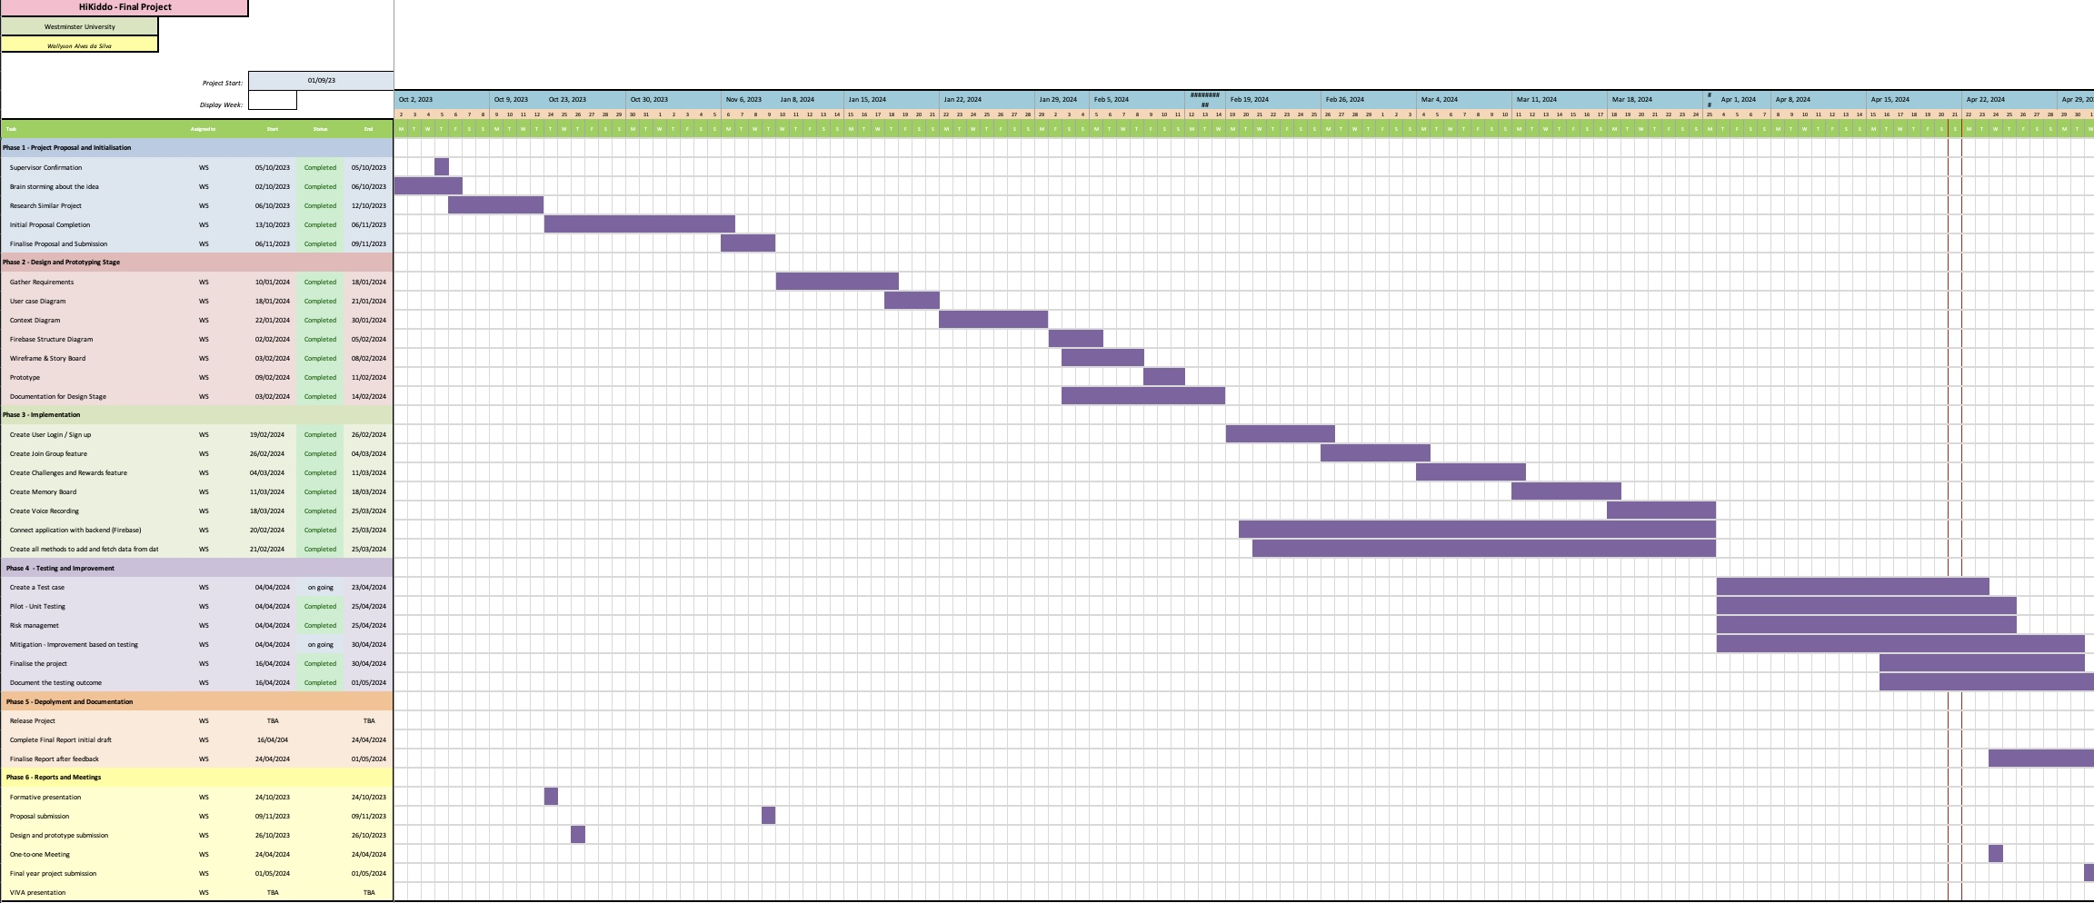

Figure 4 - Gantt Chart

Additionally, tools like Trello and GitHub played vital roles in maintaining quality control. Trello was used to enhance task management through its user-friendly boards and lists. At the same time, GitHub was essential for managing source code and ensuring systematic tracking of all changes, facilitating smooth version control and integration.

# 5. Design

## Data flow diagram

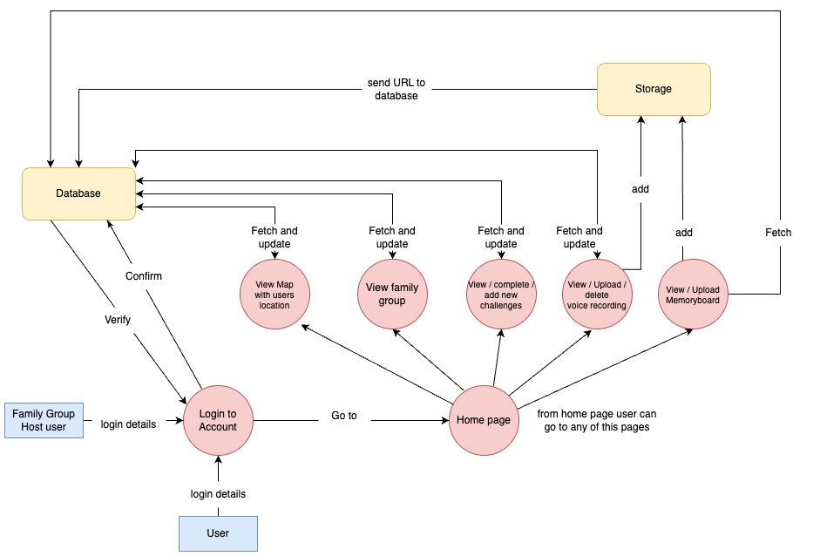

Figure 5 - Data flow diagram

The diagram above presents an overview of data interactions within the “Hikkido “application, highlighting the roles of two user types: the standard User and the Family Group Host user.

Both types of users must go through an authentication process facilitated by the Firebase, which verifies and confirms login credentials. Once users are logged in successfully, they gain access to the Home page, from which they can access all the app features.

The diagram shows how data flows between the user actions and the database, supporting the app’s functionalities. For example, users can view and interact with a map displaying the current locations of family members, manage/view family group information, participate in challenges, and use a voice recording feature for sharing stories or messages. Additionally, there is a Memory board feature for uploading and viewing media tied to family memories.

This diagram effectively shows the dynamic interaction between the user's actions and the backend response, ensuring the app functions smoothly and efficiently.

## User Interface

### **Welcome, Login & Sign-up pages**

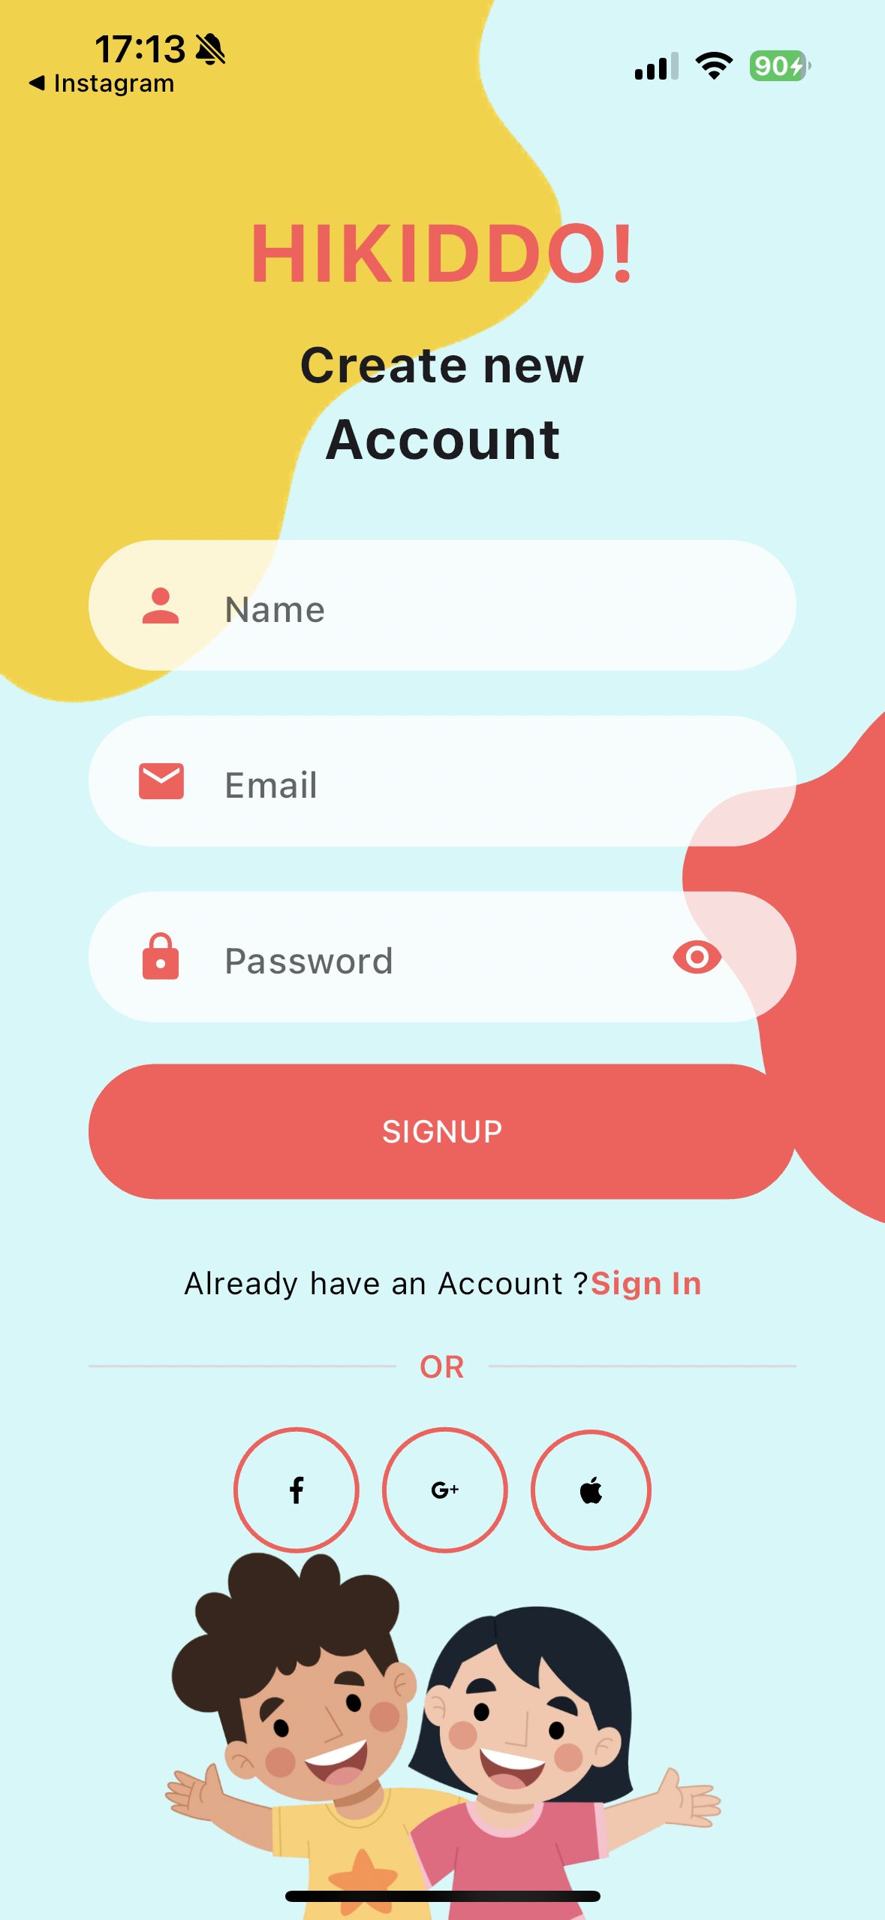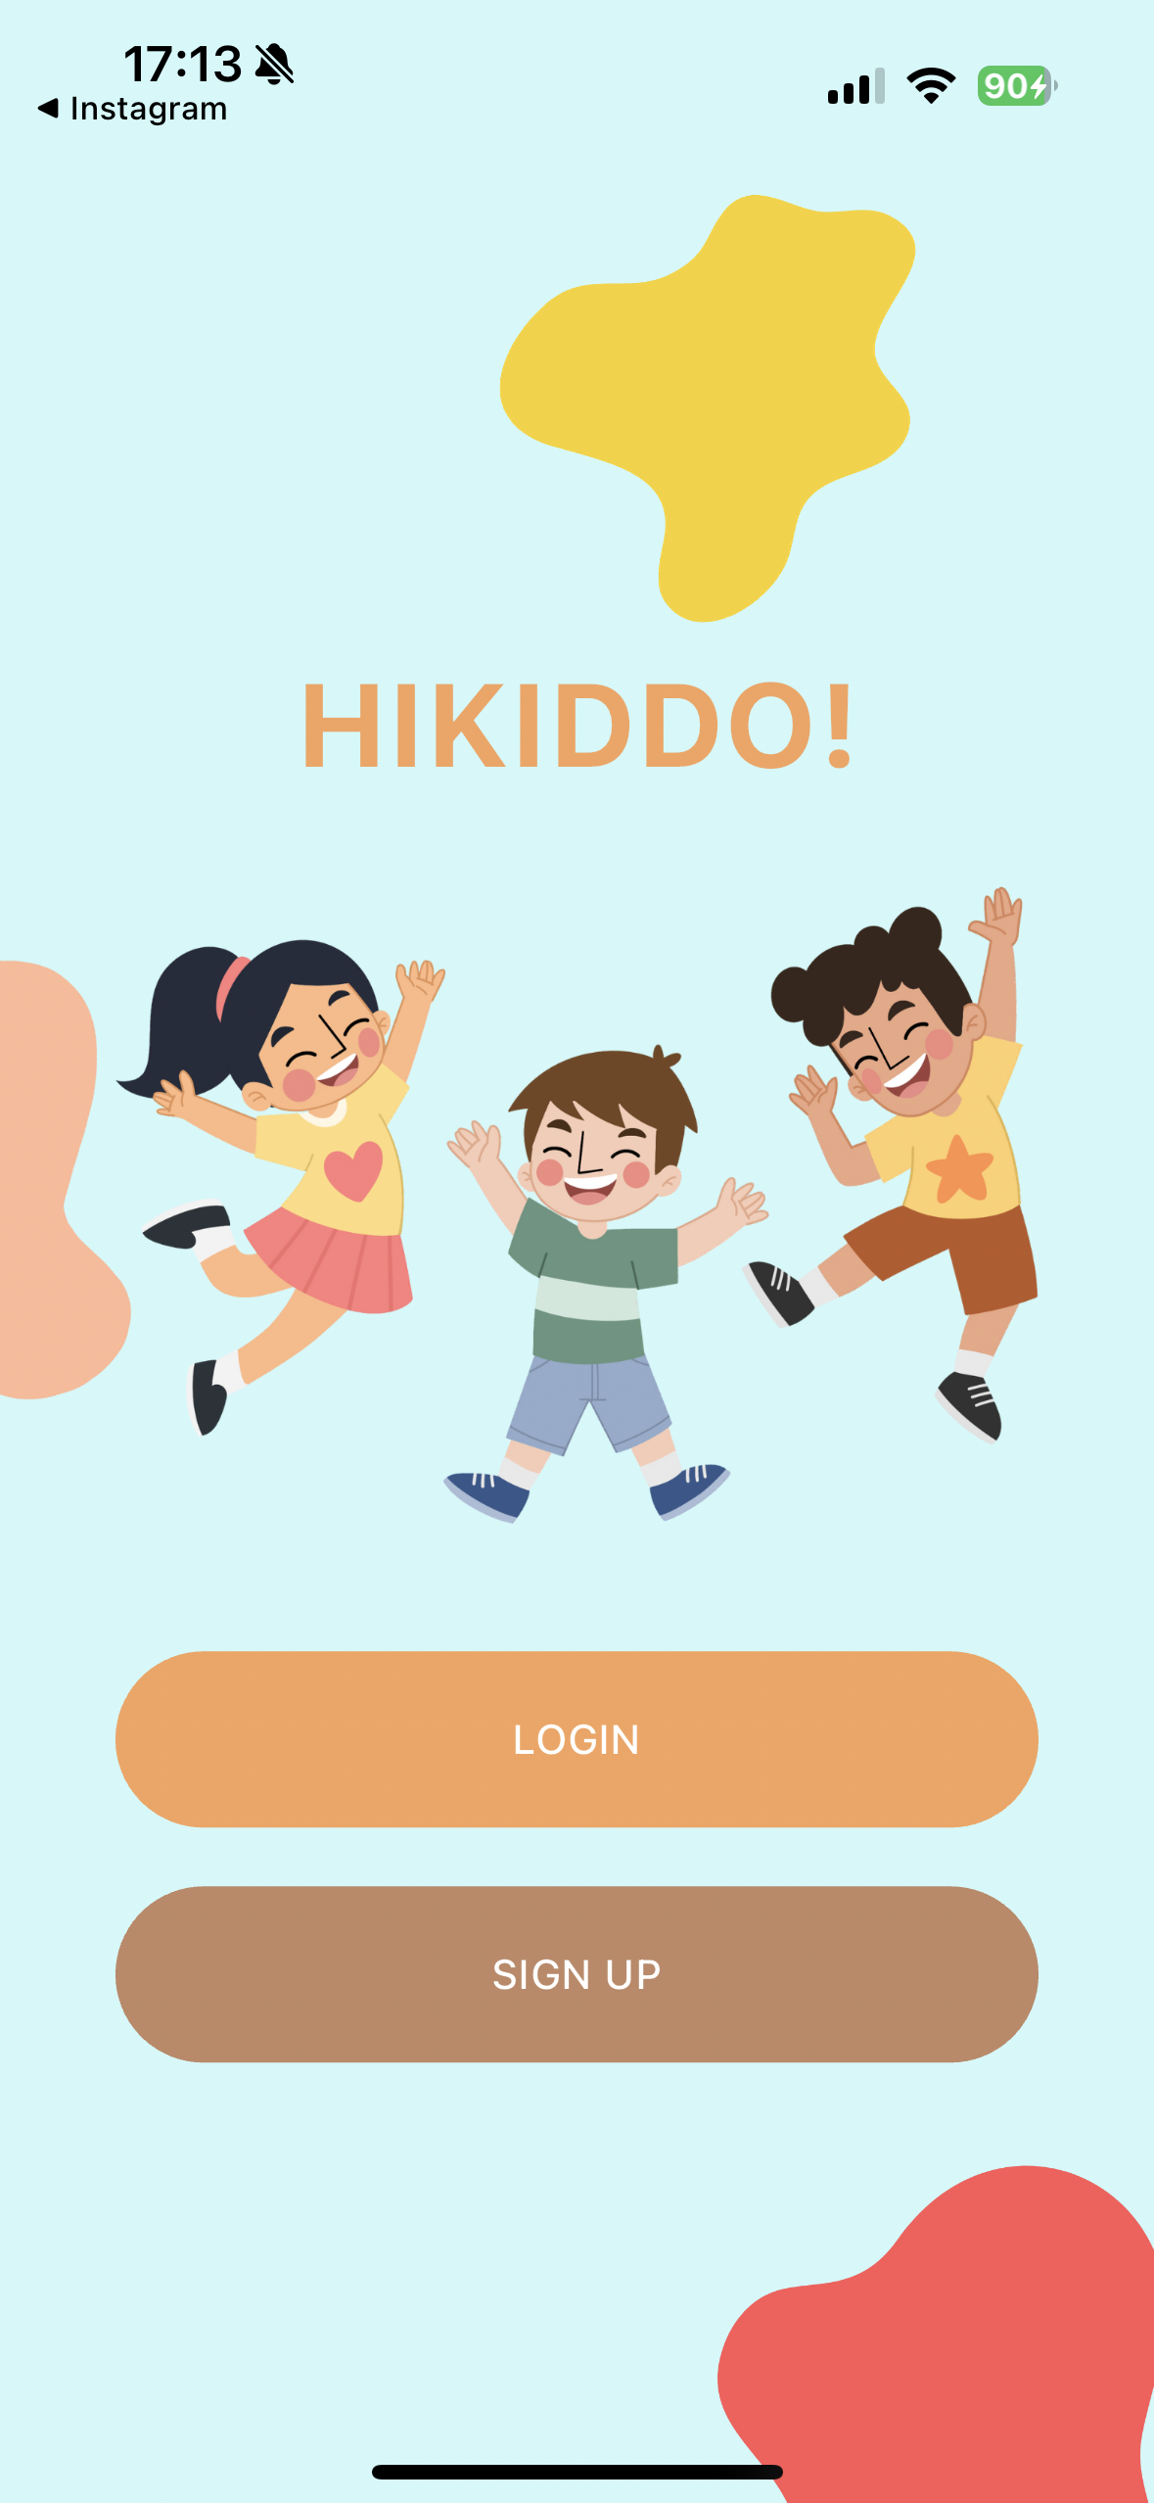 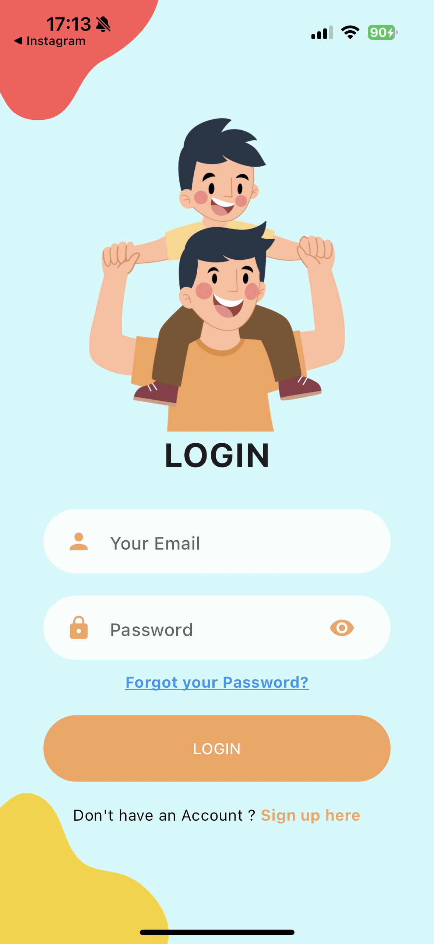

Figure 6 - Welcome, Login and Sign-up Page

This is the starting page of the application, where the initial screen presents two choices: to log in or to sign up. Selecting either option will direct the user to the corresponding page for authentication or registration.

If users already have an account, they can log in and go to the application's home page. To create an account, the user must enter their name, a valid email address, and a password. The password should be at least 6 characters long, including at least one uppercase letter and one number, to ensure security. Currently, the signup options available on this page, such as Facebook, Google and Apple, are not functioning, but enhancing these features is part of my plan.

### **Email Verification & Join Family group pages**

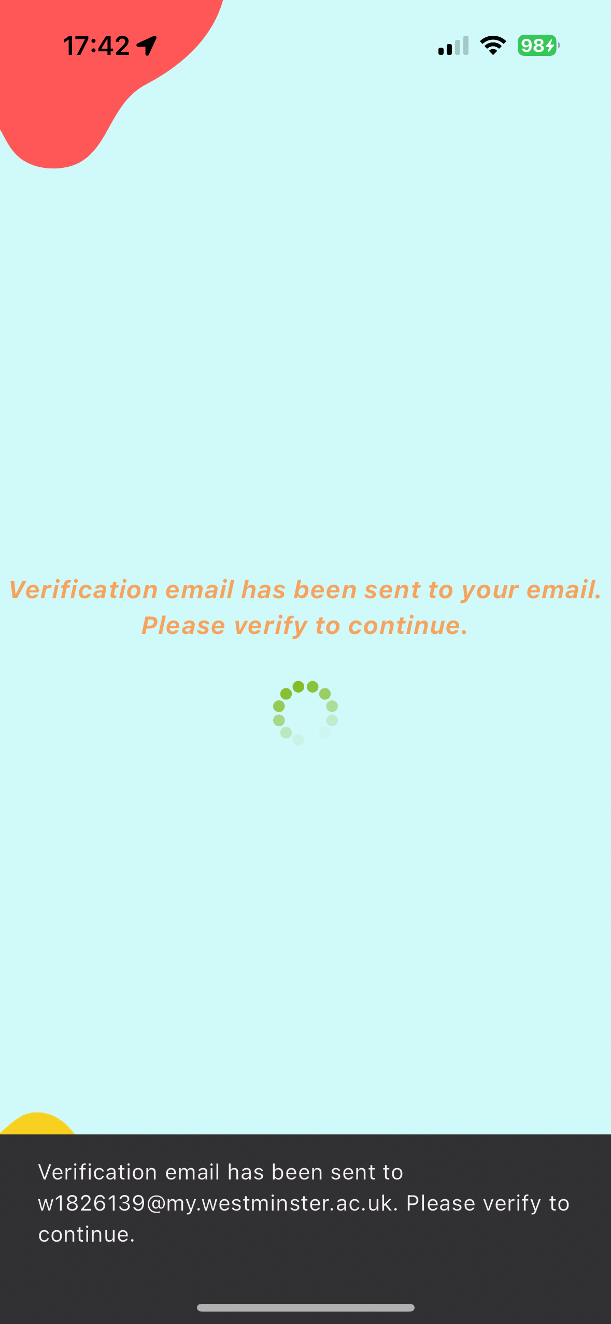 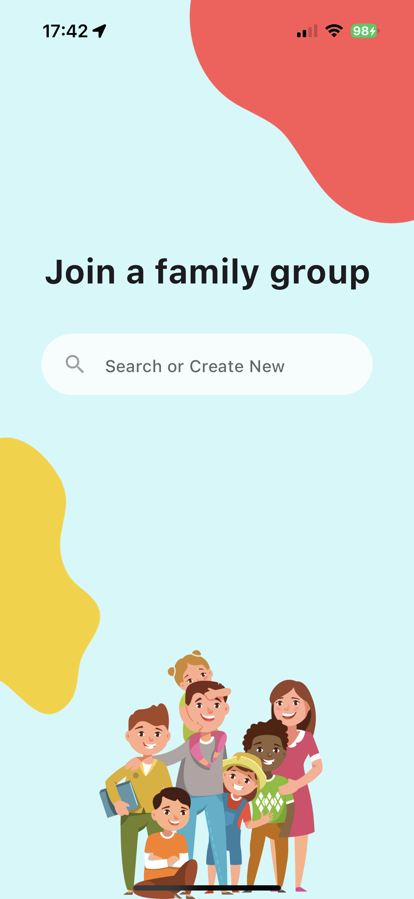

Figure 7 - Email verification and Join Family group Page

To complete the registration process, the user will be prompted to check their email for a confirmation message. They need to click on the link in the email to verify their email address. Once verified, the system will move forward to the page where they can join a family group.

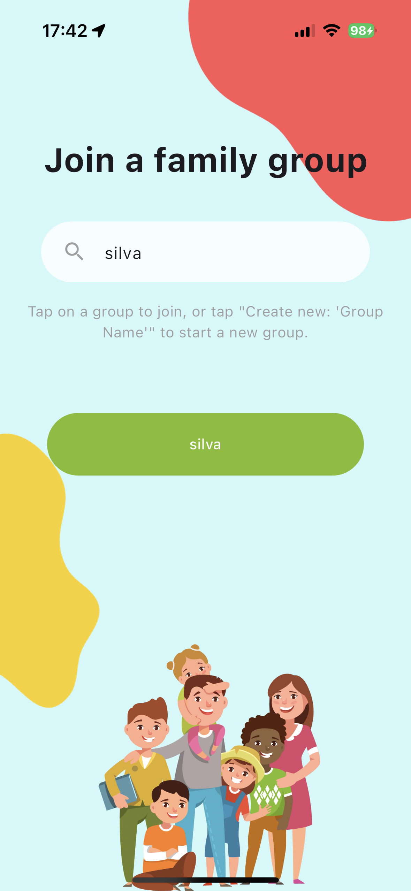 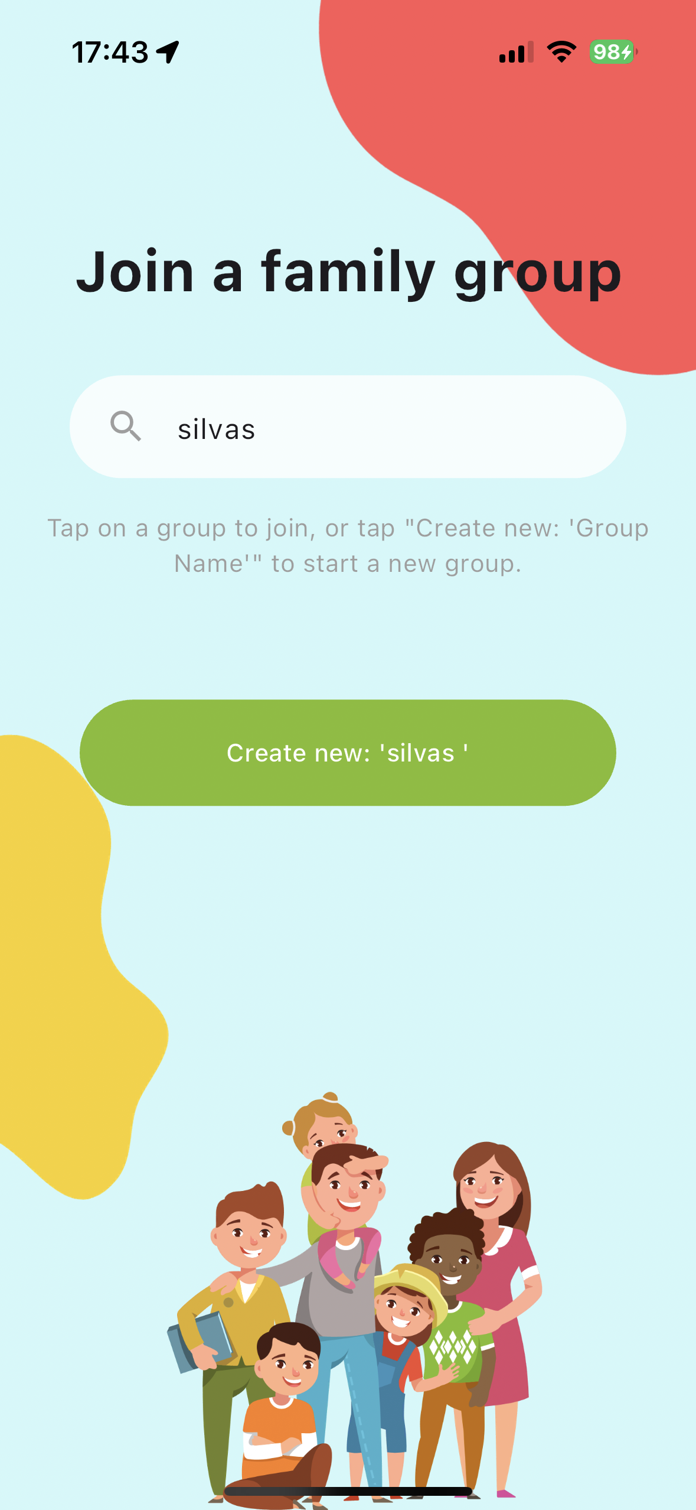 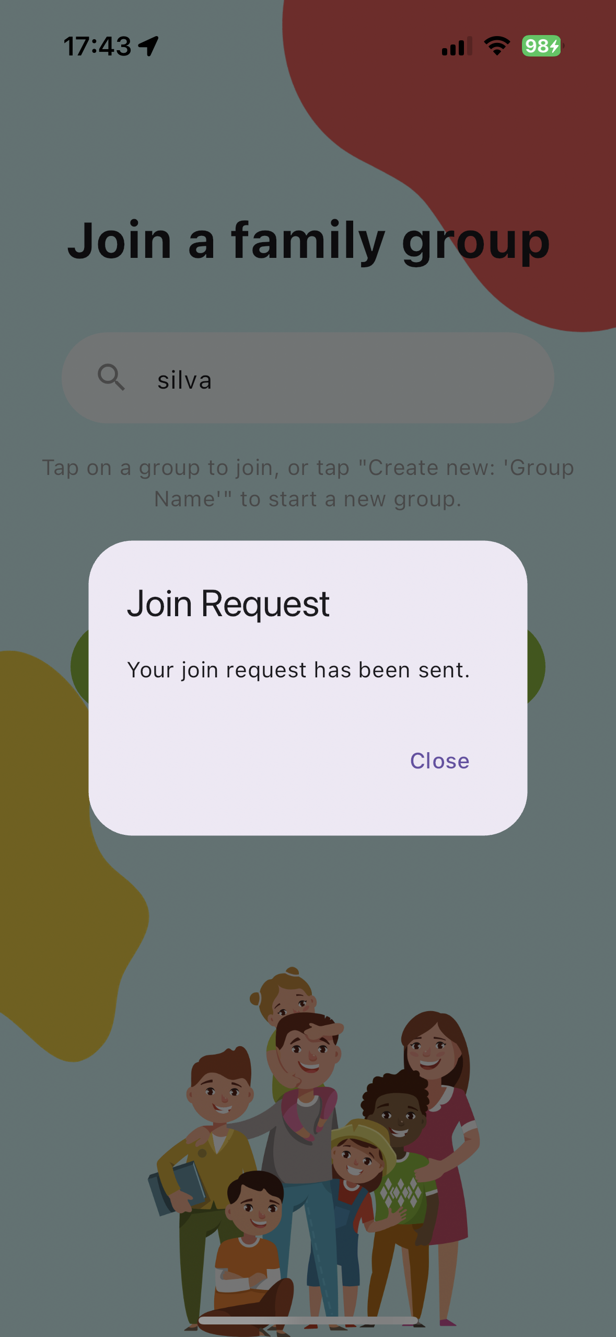

Figure 8 - Join Family group Process

On the "Join Family Group" page, users can choose to either search for an existing family group or create a new one. If a search finds an existing group with the specified name, a green button showing the name of that group will be displayed. If no existing group matches the search, a green button will appear with the option to "Create new: ‘name of the group’".

If users decide to join an existing group, they will see a join request message and must wait for approval to gain full access to the app's features. However, if they choose to create a new group, they will automatically become the host of that group and can start using the app immediately.

### **Dashboard/Home page**

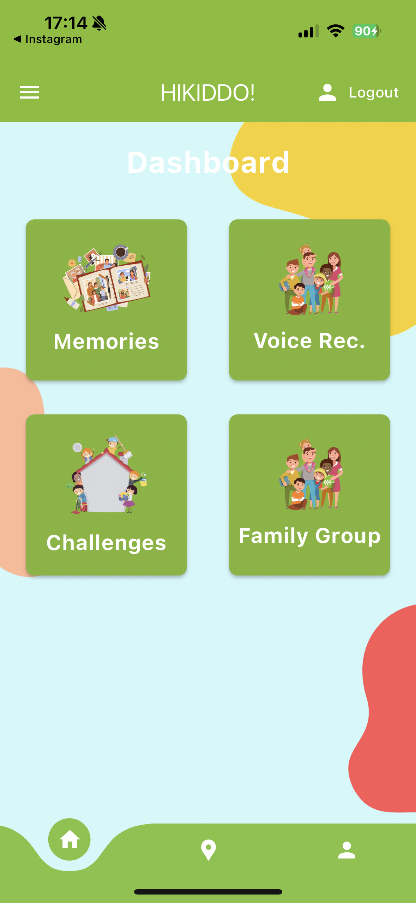

Figure 9 - Home Page

The home page is structured for straightforward navigation. It includes a bottom navigation bar that allows quick access to the home, map, and profile pages. In the central part of the page, four buttons are displayed: 'Memories' directs to the memory board feature, 'Storyteller' is for voice recordings, 'Challenges' leads to current tasks, and 'Family Group' accesses group management options. At the top of the page, a top navigation bar features a logout button and a burger menu. Opening the burger menu reveals a sidebar that links to the 'About' and 'Contact' sections.

### **Sidebar Menu, About & Contact Us sheet**

 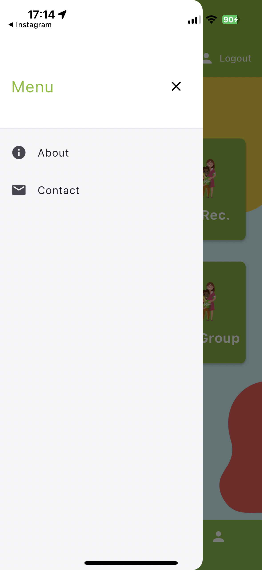 

Figure 10 - Sidebar Menu, About and Contact Us sheet

Sidebar Menu: This menu appears when you click the "burger" icon at the top navigation bar. It includes links to the About and Contact Us pages. Clicking these options brings up a bottom sheet with the relevant information. For instance, on the Contact Us page, to reach out to the Hikiddo support team, just click on the email link. This will open your email application, allowing you to compose and send an email directly. Refer to the image above to see examples of how this setup looks.

The email address "support@hikiddo.com" is provided here as a hypothetical example for illustrative purposes only.

### **Profile & Location pages**

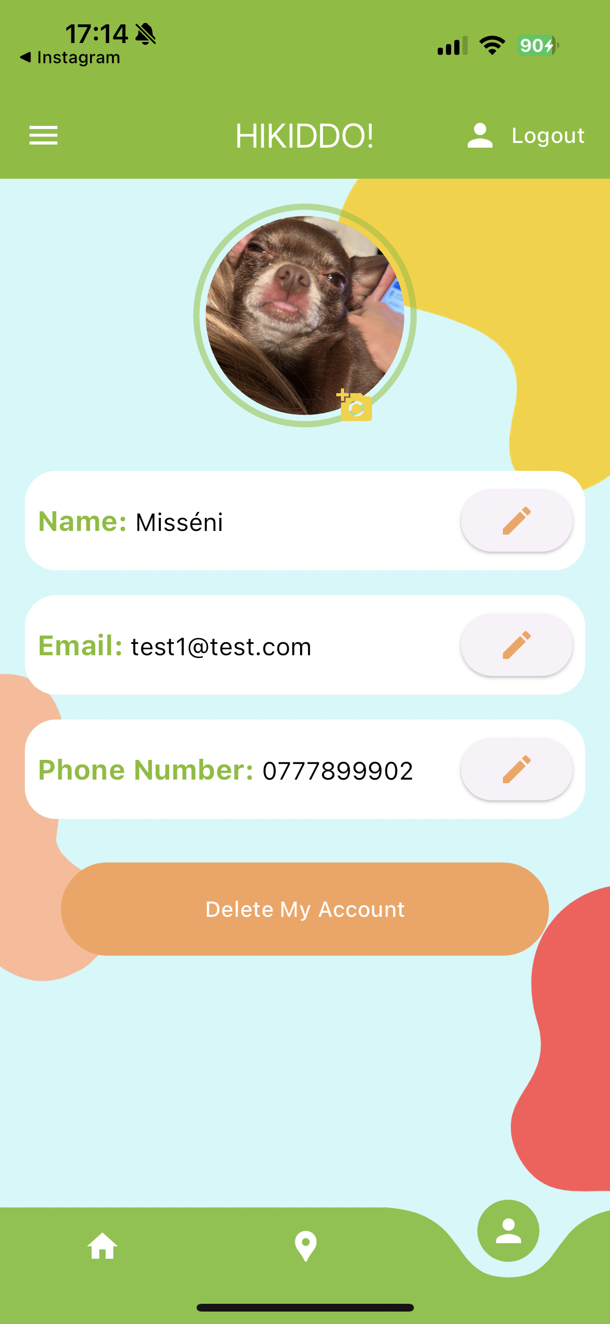 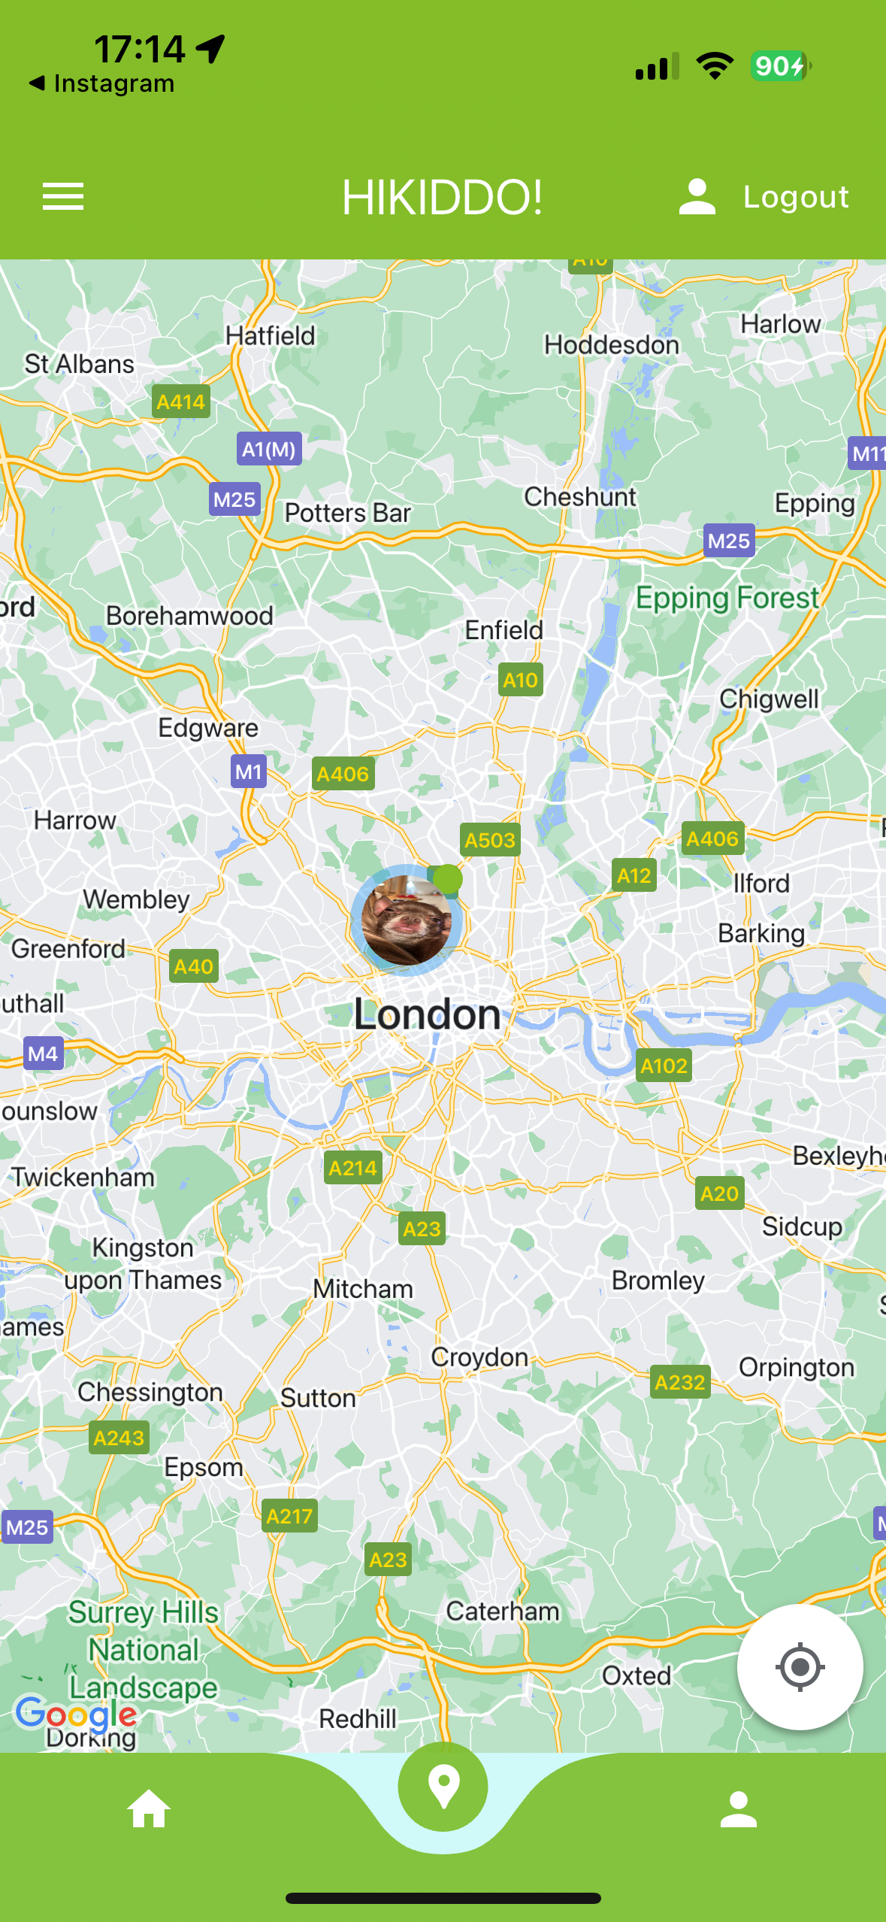

Figure 11 - Profile and Map view pages

Profile Icon in the Bottom Navigation Bar: This section displays user information and the options to update their name, email, and phone number. Users can also upload a profile picture, which will appear as their avatar on the location pinned in the map view. Additionally, on this page, there is an option to delete their account.

Location Icon in the Bottom Navigation Bar: This section displays a Google Maps view, showing the current locations of all family members on the map. It's important to note that the zoom-in and zoom-out features might not work as smoothly in the mobile simulator as they work in the fully deployed mobile app version.

### **Family Memories Page (Memory board)**

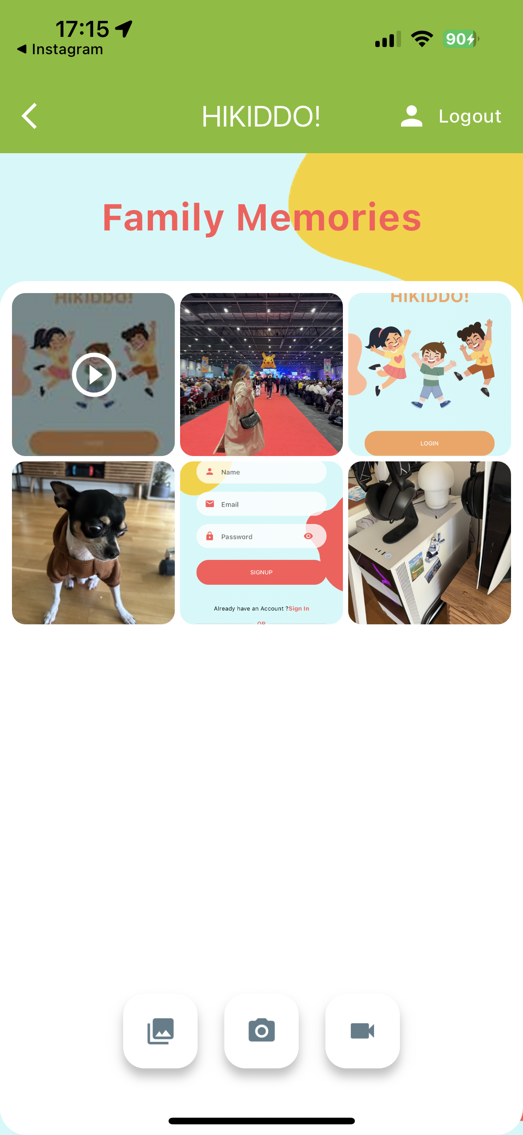 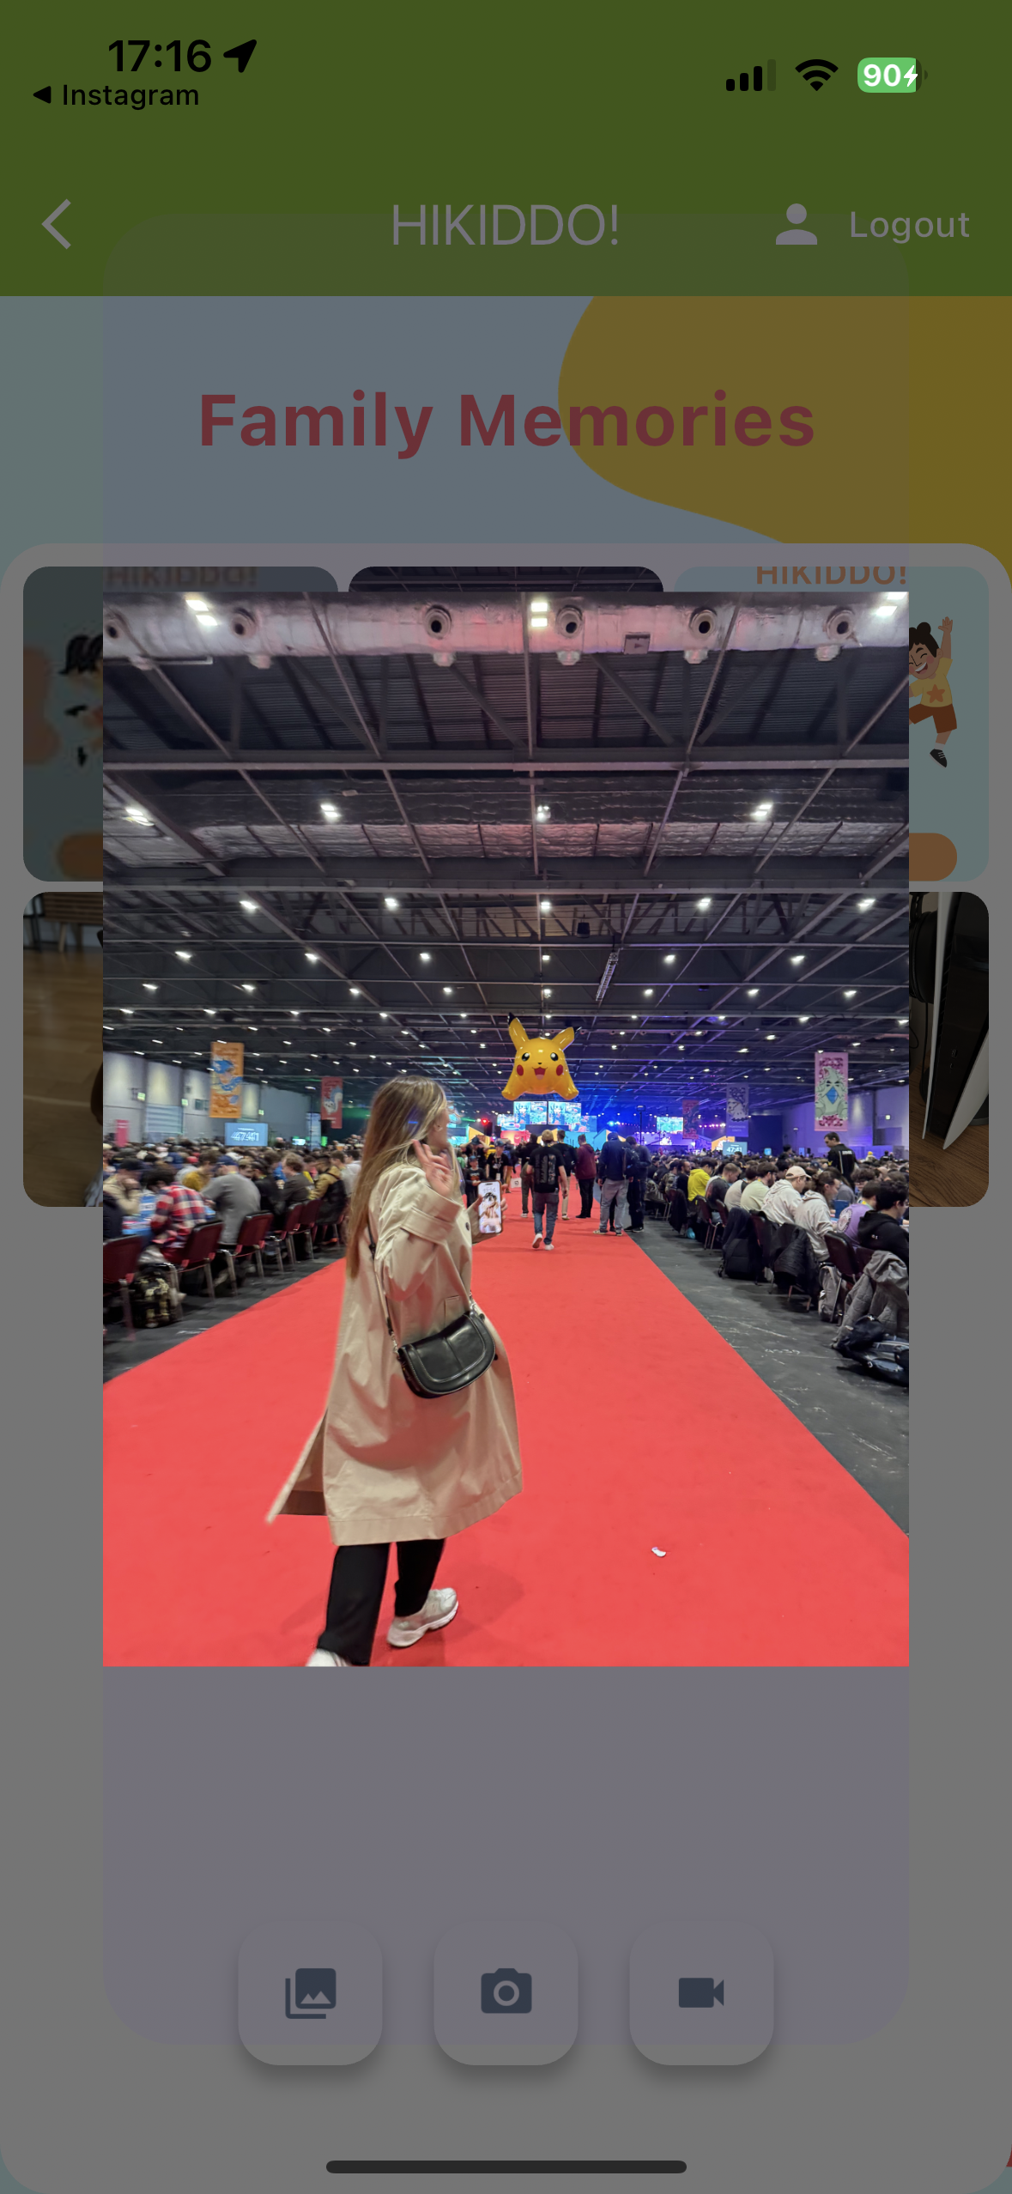

Figure 12 - Family Memories Page

Memories: This feature offers a place for users to share and preserve family memories. They can upload videos or photos from their gallery or capture new moments using the camera icon for photos and the video icon for videos. To view a photo or video in more detail, click on and that media will be displayed on a large scale; clicking on a video will start the auto-play, with a replay button appearing after the video ends.

### **Family group page**

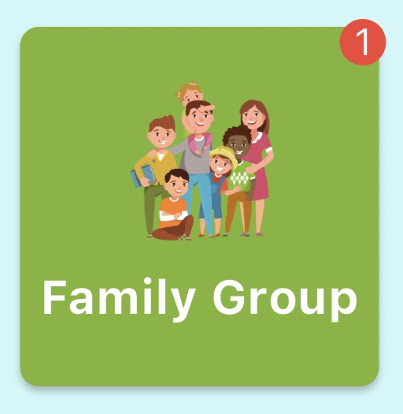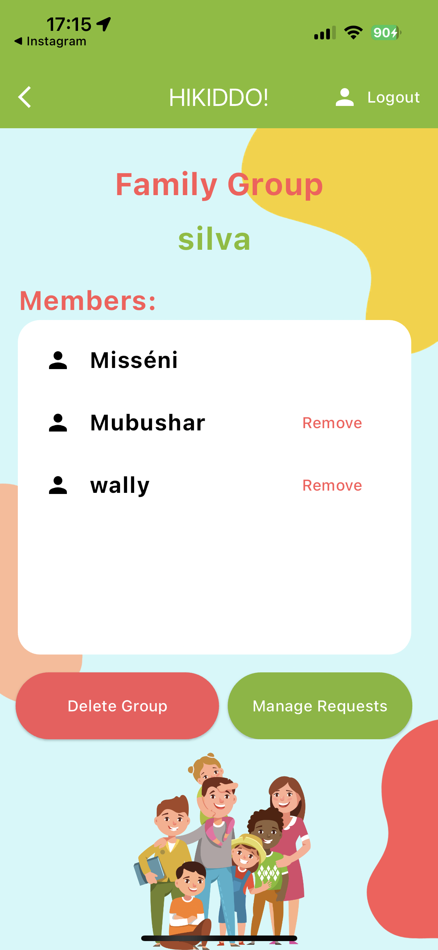

Figure 13 - Family group Badger when there is a new request to join

Family Group: In this section, users can view all the members of their family group and have the option to leave the group if they wish. When the host user accesses this page, they have additional privileges, including removing a family member from the group, accepting or declining new members, and deleting the entire group. If a user chooses to delete the group, all information related to this group will be removed from the database, although this action does not delete the user's account.

Figure 14 - Family Group Page

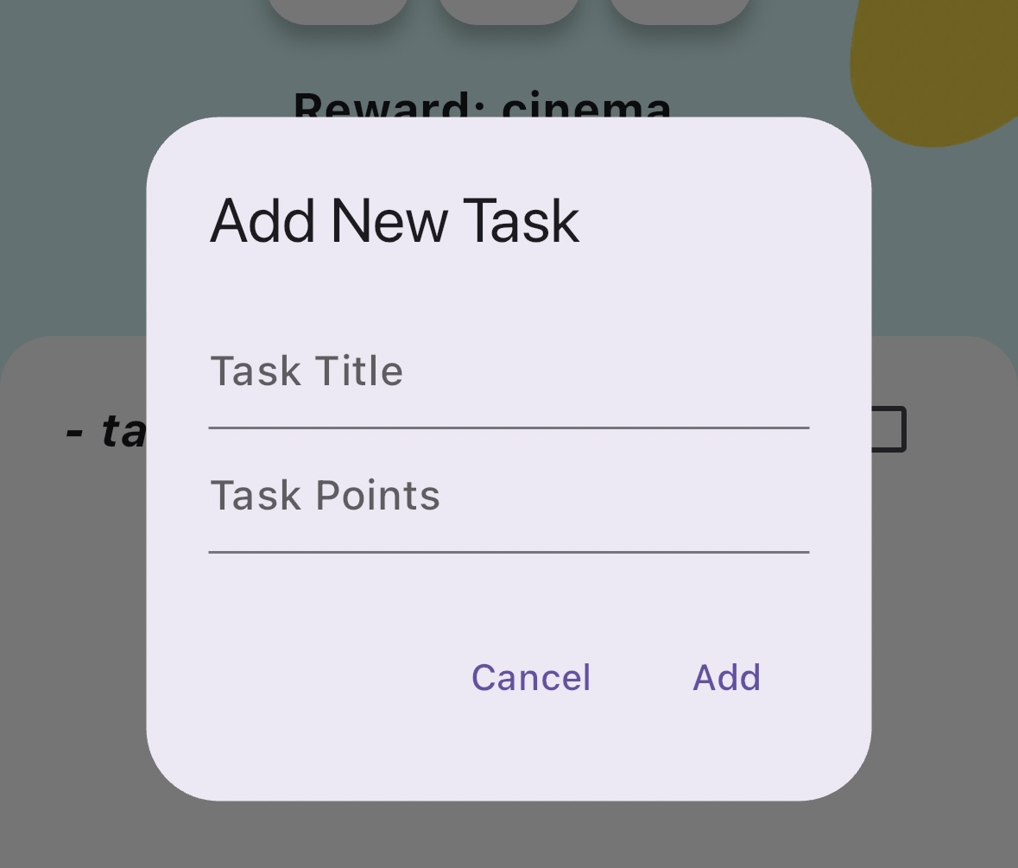**Challenges page**

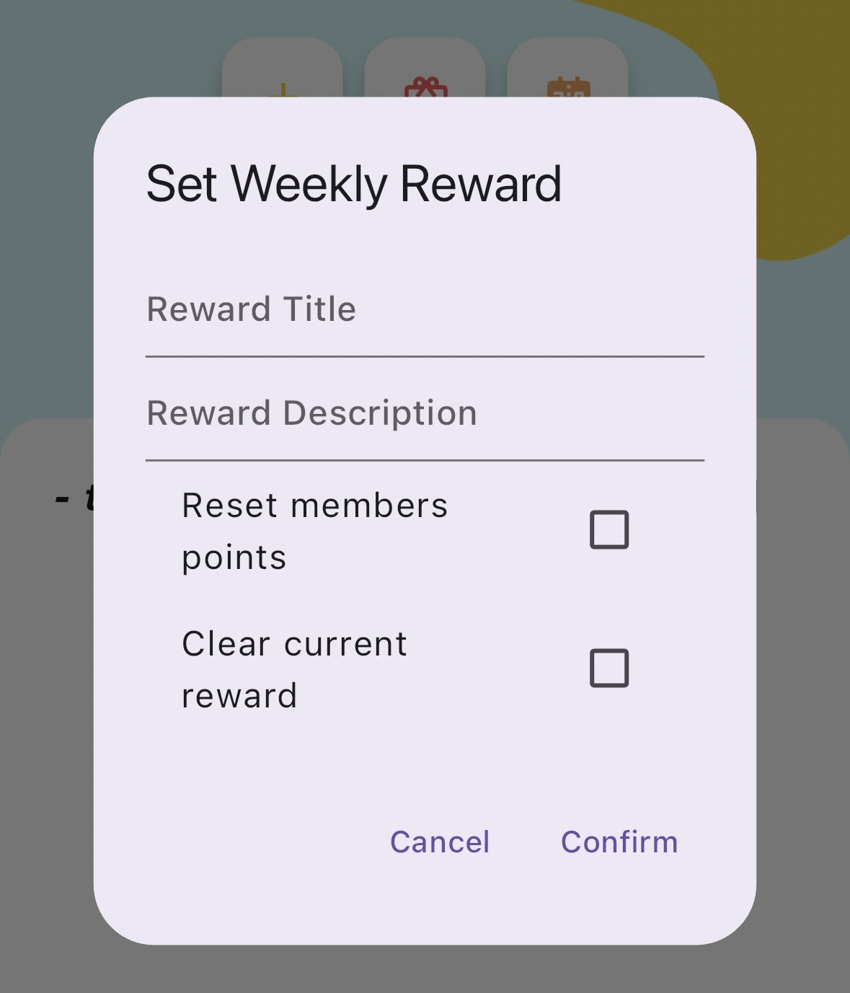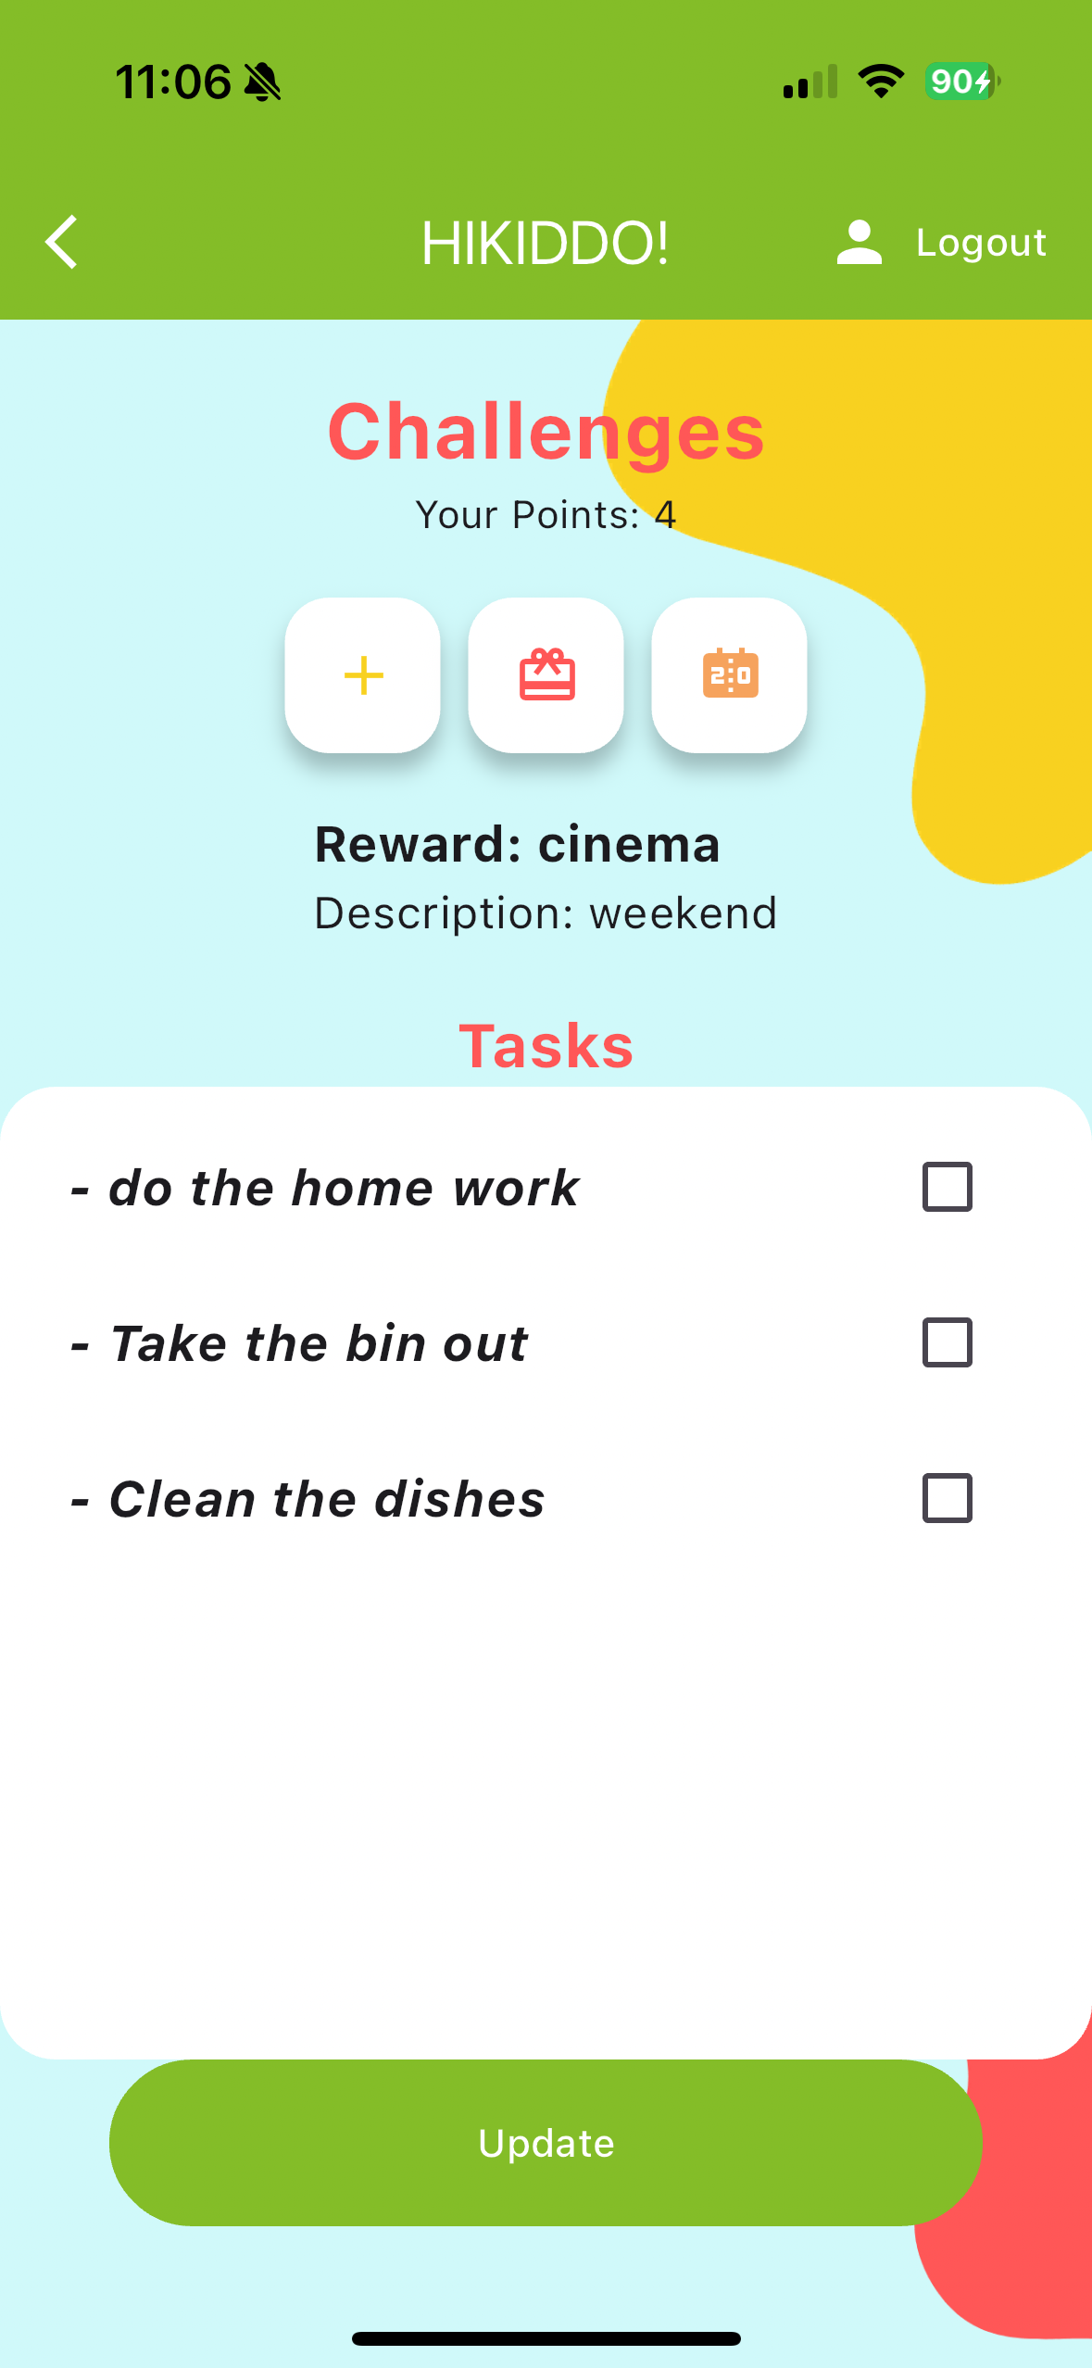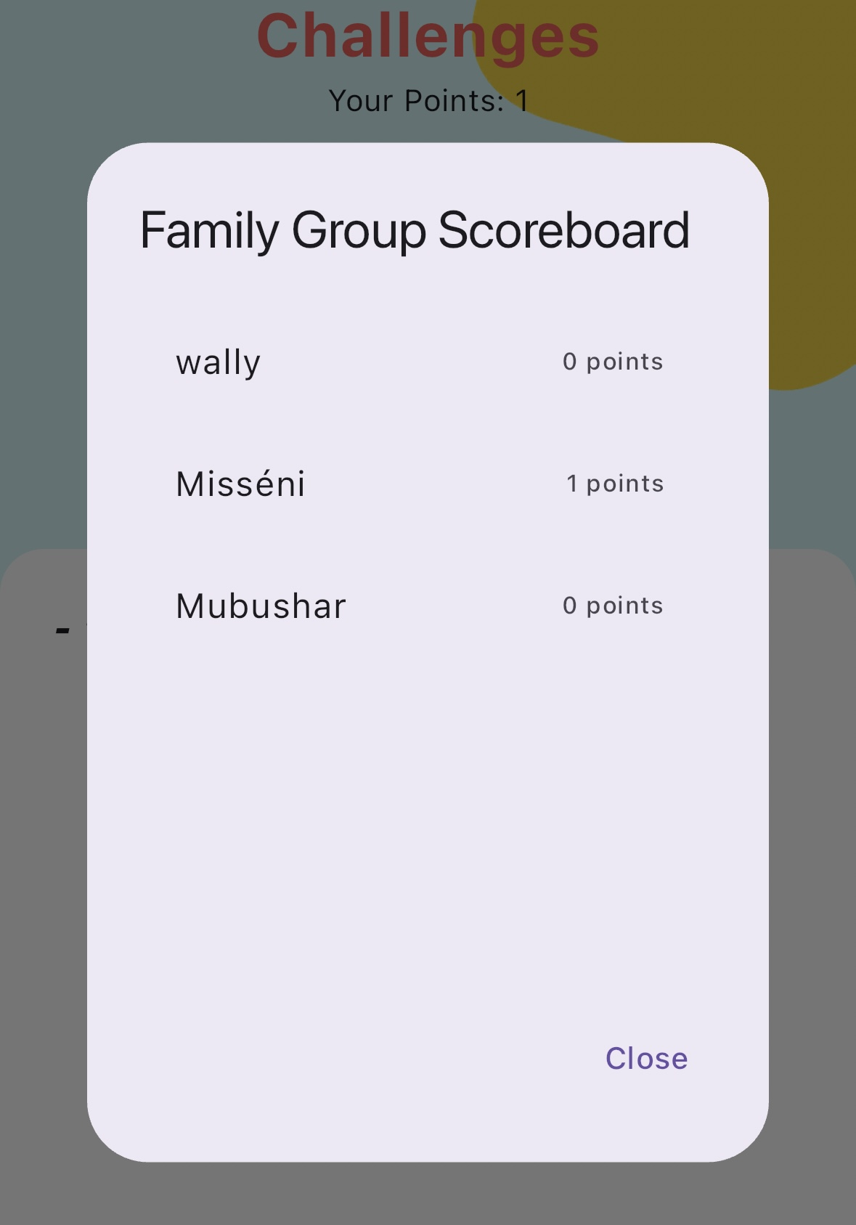

Figure 15 - Challenges Page, From Host View

Challenges: This page allows users to complete tasks, earn points, and receive rewards set by their parents. Host users have additional privileges, such as the ability to add or update weekly rewards, clear points, introduce new tasks with set point values, and view the family group scoreboard. This feature is designed to not only motivate and engage family members by tracking and rewarding their accomplishments but also for the parents to create a sense of education behaviour and teach basic life skills to their kids.

**Storyteller page (voice recording feature)**

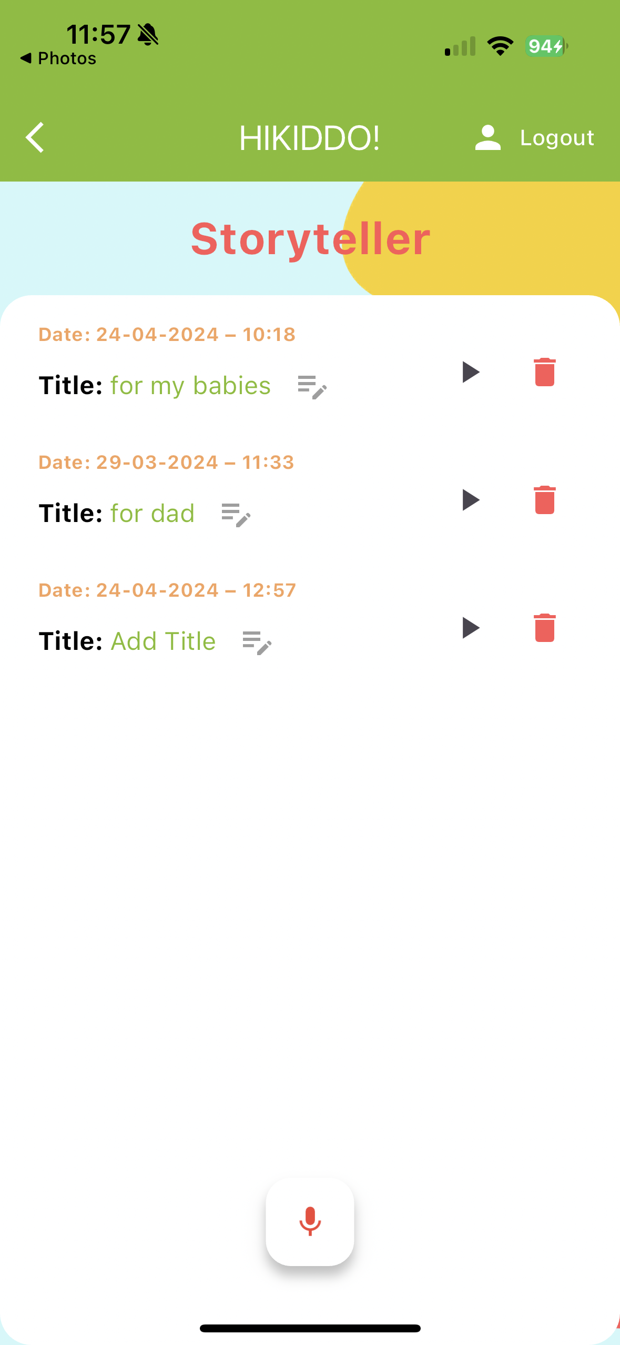 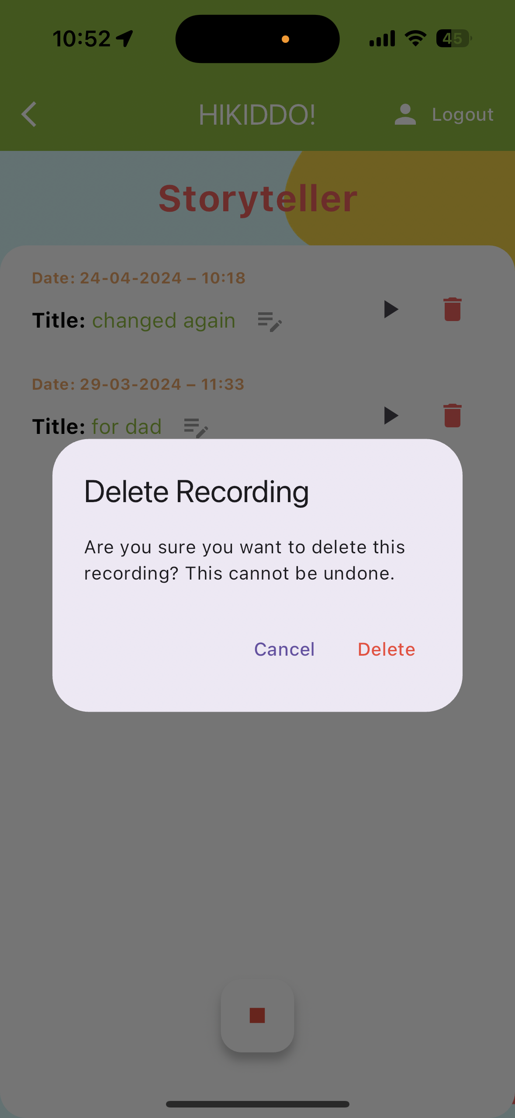

Figure 16 - Storyteller Page (Voice recording feature)

Storyteller: This feature enables users to record meaningful messages for their loved ones or create bedtime stories for children to listen to at night. Every member can contribute by adding a recording and editing its title. Each recording has a play button for easy listening and a delete button for removal. The delete and add a title option are available to the host user and the user who made the recording.

## Sequence Diagram

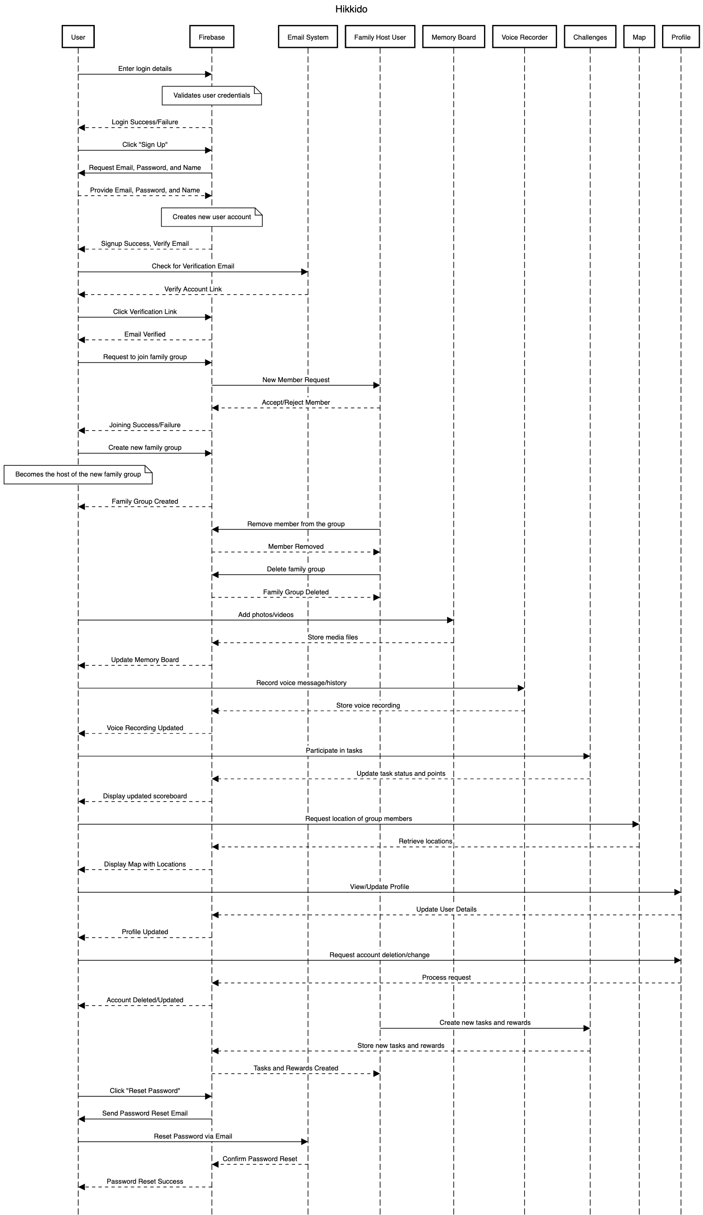

Figure 17 - Sequence Diagram

The use of a sequence diagram in developing the Hikkido mobile application is crucial. It provides a visual representation of the sequence of operations, interactions between system components, and user actions, facilitating a clearer understanding of the app's functionality and flow.

Essential interactions in the Hikkido mobile application include:

* Users log in with their details, which Firebase verifies. New users can sign up with an email, password, and name. They must verify their account via a confirmation link sent via email.
* Users can request to join a family group, which the Family Host User can approve or deny. Users also have the option to create a new family group and become its host.
* Once authenticated, users can engage with app features. They can upload photos and videos to the Memory Board, record voice messages, participate in challenges completing the task created by the host user, and see group members' locations displayed on the map.
* Users can view and edit their profiles or delete their accounts. Additionally, if users forget their password, they can reset it via a link sent to their email.

# 6. Tools and implementation

## 6.1 Tools

To develop the "HiKiddo" app, I ventured into new technological territories as I was predominantly familiar with Kotlin and iOS development from my previous mobile programming modules. Through the research for the development of this project I was introduced to Flutter and Firebase, technologies that were new to me but essential for achieving the desired functionality and user experience of the app.

Tools and Technologies Used:

### **Flutter & Dart**

Flutter, powered by the Dart language, was chosen as the primary framework for developing "HiKiddo". It allowed for the creation of a visually attractive and responsive user interface for both Android and iOS platforms from a single codebase. Dart's syntax and functional programming aspects intrigue me as opportunities to step out of my comfort zone and immerse myself in learning a new language and framework.

### **Firebase**

Firebase was utilised as the backend for the "HiKiddo" app, offering key services, including authentication (firebase_auth), database management (cloud_firestore), and file storage (firebase_storage). This integration is particularly beneficial as Firebase pairs seamlessly with Flutter, streamlining the development process. It facilitates real-time data synchronisation, critical for the app's features and regular updates. Additionally, Firebase’s authentication module boosts security by effectively managing user sessions.

The decision to pair Firebase with Flutter for the "HiKiddo" app was driven by several considerations:

Unified Codebase: Flutter’s ability to let developers build apps for both iOS and Android from a single codebase combines well with Firebase’s versatile backend services.

Scalability and Ease of Use: The scalability of Firebase and the straightforward UI capabilities of Flutter combine, creates a powerful and user-friendly development environment, perfect for building "HiKiddo".

### **Google Maps Platform**

Google Maps API, known for its extensive mapping capabilities, was integrated into the app to enhance location-based features, allowing users to view each other's locations in real time.

### Dart and Flutter packages used:

*flutter_svg*: A rendering and widget library for Flutter that enables the painting and display of Scalable Vector Graphics. Used to display Google, Apple and Facebook logos.

*location, geolocator*: This is used to access devices' location and geolocation features easily.

*permission_handler*: This plugin provides a cross-platform (iOS, Android) API to request and check permissions.

curved_navigation_bar: To enhance the UI/UX with appealing icons and navigation bars.

*Provider*: Allows widgets to listen to changes in model or data objects and rebuild when those objects change.

*image_picker, firebase_storage*: To upload and store images.

*google_maps_flutter*: To integrate Google Maps into the app.

*file_picker, video_player, video_thumbnail*: For managing media files.

*flutter_sound*: used to handle audio recording and playback operations.

path_provider: This package finds the correct file paths for storing app data on mobile devices.

audioplayers: this package allows for playing audio files from assets, files, or URLs.

*intl*: It provides tools to format dates, numbers, and strings.

### **New Skills Developed**

My background in Kotlin and experience with iOS frameworks provided a strong foundation that helped me quickly understand the basic concepts necessary for mastering new platforms like Flutter and Firebase.

I had to learn both Flutter and Firebase from scratch. For Flutter, I started with the fundamentals, learning Dart programming and how to effectively utilise Flutter widgets by exploring documentation and following detailed tutorials on YouTube. Simultaneously, I worked on gaining expertise in Firebase, which was vital for securely and efficiently managing user authentication and data storage.

I enhanced my user interface design skills by using Flutter libraries like *curved_navigation_bar* and *flutter_spinkit*, which improved the app's visual appeal and functionality. I also learned to integrate comprehensive mapping and location tracking features using the Google Maps API and managing location data with geolocator effectively. Additionally, I developed skills in multimedia management by utilising tools such as Flutter’s video_player and flutter_sound, allowing for the inclusion of voice recording and video recording features that enriched the user experience in the "HiKiddo" app.

## 6.2 Implementation

This section of the document provides an overview of the key elements used in the project, explaining what each part is supposed to do and the structure of the project. It is worth mentioning that not every piece of code is covered in detail here, but the main methods used are outlined. For instance, one of the first steps was to set up the Firebase configuration, which can be done on the Firebase website.

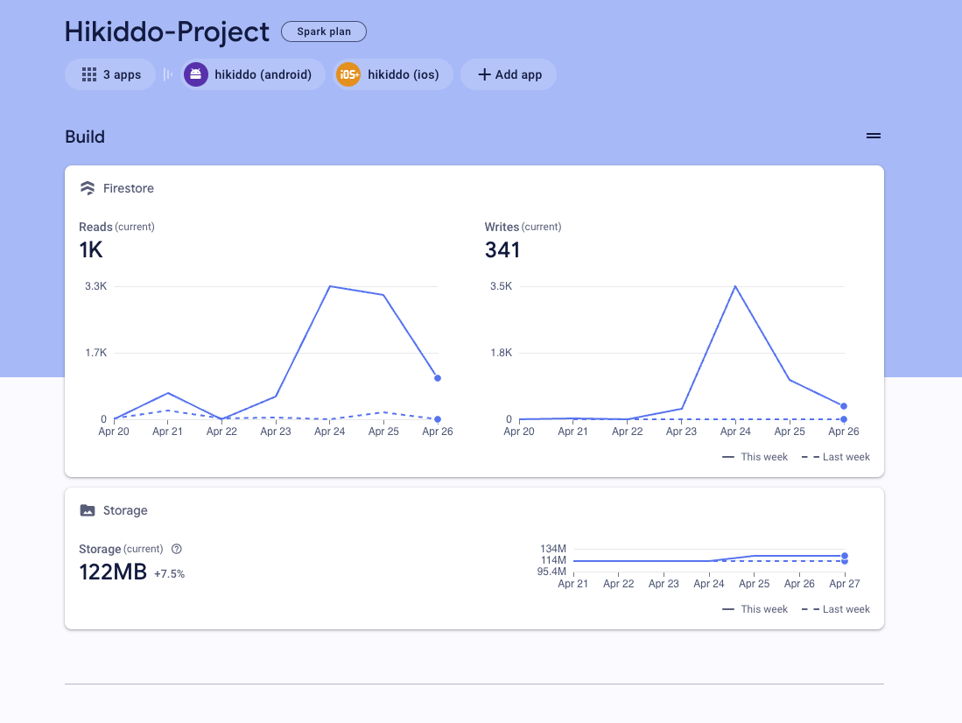

Figure 18 - Firebase Build

During the early stages of development, Firebase services were configured to utilise a range of features. The Firebase database and Firebase Storage were set up to manage and store data efficiently, including various file types such as photos, videos, and voice recordings. Additionally, the Authentication service was activated to create a secure and reliable user login system, which is vital for protecting user data and controlling access features of the application.

Linking the project to Firebase by registering the application is essential. This registration process includes generating unique keys for Android and iOS by providing Firebase with the application’s ID, ensuring integration across multiple platforms.

In the image above (Image X), the traffic of database usage over the last week and the storage usage are shown.

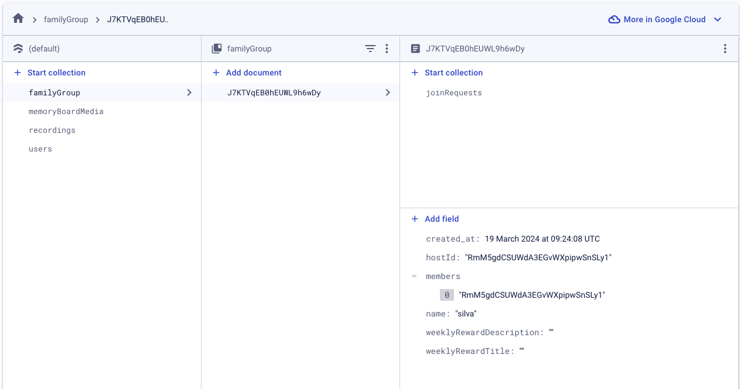

Figure 19 - Firestore Data structure

Referring to Figure X, the diagram shows how the database's data structure is organised into four main collections: "FamilyGroup", "memoryBoardMedia", "recordings", and "users".

The **FamilyGroup** Collection stores details about each family group, including the creation date, host ID, list of member IDs, group name, and information about weekly rewards like descriptions and titles. This collection also contains a subcollection, "joinRequests," which is used to manage new members' requests to join the group.

The **MemoryBoardMedia** Collection is set up to organise information about photos and videos stored in Firebase Storage. Each document in this collection includes several important details:

familyGroupId: Identifies the specific family group that the media belongs to, ensuring that media content is accessible only to authorised family members.

isVideo: Specifies whether the file is a photo or a video.

mediaUrl: Provides the direct URL to the media file in Firebase Storage.

timestamp: Indicates the time when the file was uploaded.

The **Recordings** Collection is set up to organise information about the voice recordings stored in Firebase Storage. Each document in this collection includes several important details:

familyGroupId: Identifies the specific family group that the media belongs to, ensuring that media content is accessible only to authorised family members.

fileUrl: Provides the direct URL to the file in Firebase Storage.

Title: This attribute stores a name to the recording file, making it easier for users to identify and access specific recordings within the application.

Date: Indicates the time when the file was created.

The **Users** Collection is crucial for storing details about the individuals using the application. The collection links each user to a specific family group through the familyGroupId, ensuring they can access appropriate group-related features and content. It also stores the URL of the user's profile picture in the imageLink field. This same profile picture is used to identify the user on the map.

Additionally, the collection records the latitude (lat) and longitude (lng) of the user's location, which are crucial for the application's location-tracking features. The locationUpdateTimeStamp field captures the time when the user's location was last updated. The points field was created to track the points earned by the user through completing tasks in the challenges feature. Lastly, the user's name, email, and phone number are stored within this collection**.**

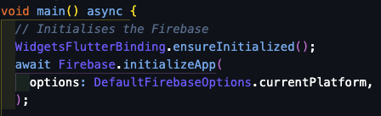

Figure 20 - Firebase connection with the project

After setting up Firebase, it's necessary to connect the project to the database. The process is shown in the figure above, where the Firebase.initializeApp() method is used. This asynchronous method initialises Firebase with default settings based on the platform in use. This step is crucial for enabling all Firebase-related functionalities within the app.

## Project Folders Structure

To provide a clearer insight into the design and structure of this project, the organisation of files and code will be detailed. This overview helps illustrate the systematic approach taken in implementing the “Hikiddo” project codebase.

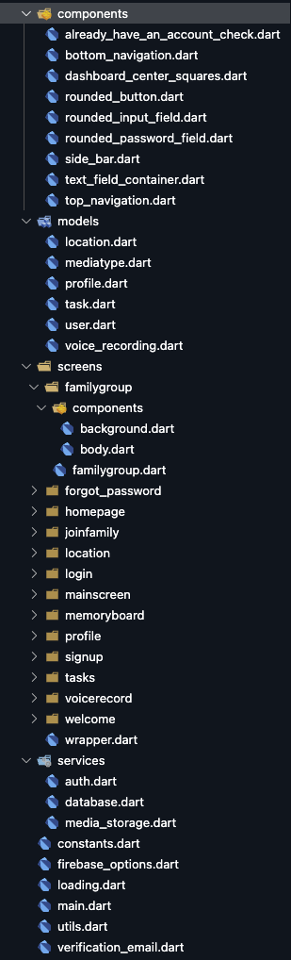

The **/models** directory contains files that define the structure of the data corresponding to the collections in your Firebase database.

The **/screens** folder is organised to hold a list of subfolders for each view of the application, such as login, signup, profile, and more. Each subfolder in most cases includes a **/components** folder with the Dart files that develop the UI and the logic for that specific screen.

The **/services** folder is designed to separate core functionality from the UI code. Inside this folder are all the main methods related to the database, authentication, and media storage.

The **/components** directory contains reusable widget files designed to be shared across different parts of the app.

Figure 21 - Project folder structure

## Code Implementation

**Main.dart**

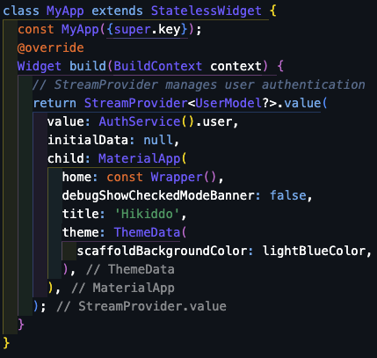

Figure 22 - main.dart

The main.dart file is the entry point for Flutter applications and is responsible for setting up essential configurations at start-up. It features a StreamProvider widget that monitors changes in user authentication state through AuthService().user. The authentication stream checks the user's login status at start-up. Depending on whether a user is logged in, the application utilises the Wrapper widget to direct the user to the correct screen. It displays the MainScreen() for users who are logged in and the WelcomeScreen() for those who are not. This approach ensures that users are seamlessly navigated to the appropriate page based on their authentication status.

**/signup/components/body.dart**

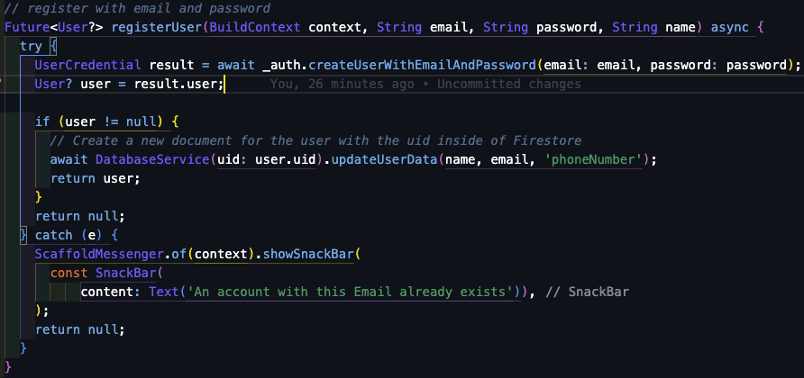

Figure 23 - Method to Register User

On the Sign-Up page, when the "sign up" button is pressed, it triggers a method that begins the user registration with the _auth.registerUser() method using the provided email and password. Before proceeding, the FormField is validated to ensure that the information entered meets the required criteria. If the user is successfully created, the application sends a verification email. Simultaneously, it starts a Timer that checks every 5 seconds to see if the user's email has been verified. Once _auth.isEmailVerified(user) confirms the verification, the Timer stops. The application then exits the loading state and navigates to the JoinFamilyScreen() page. This effectively replaces the current route, moving the user through the sign-up process without the option to return to the previous screen.

Figure 24 - Sign-up Button on press function

**/login/components/body.dart**

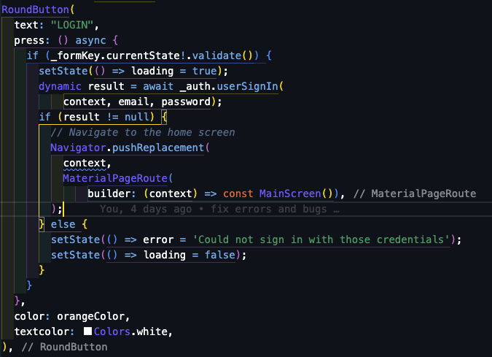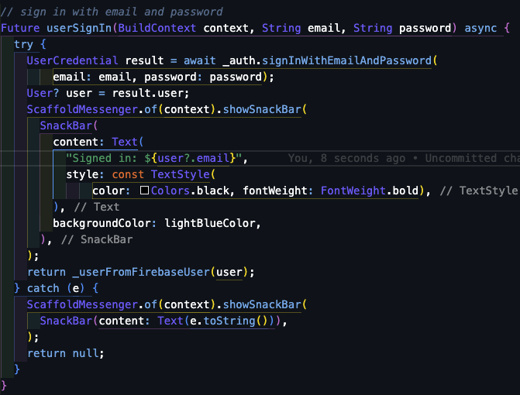

Figure 25 - Login method

The method outlined in the Figure 25 manages user sign-in for the application. When the "Login" button is pressed, a loading animation is activated to indicate that the process is underway. It then proceeds to sign in the user with the _auth.userSignIn function, using the provided email and password.

If the sign-in is successful and a user object is returned, the application navigates to the MainScreen using Navigator.pushReplacement, ensuring the user cannot navigate back to the login screen. If the sign-in attempt fails, a null result will be returned, and the application updates the error state to display a message about the invalid credentials and turns off the loading animation. During the sign-in process, if the user is successfully authenticated, a SnackBar is displayed to confirm the logged-in, providing visual feedback showing the user’s email.

**/screen/joinfamily/components/body.dart**

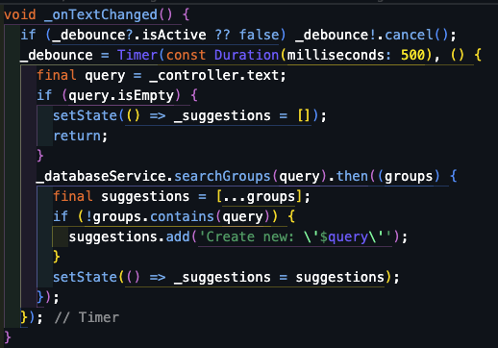

Figure 26 - Join Family method

The _onTextChanged method handles changes in user input within a search field for the family group. It starts by checking for an existing debounce timer, _debounce. If this timer is found to be active, it is cancelled to prevent the method from executing multiple times. This timer is then set with a 500-millisecond delay, creating a brief pause. This pause allows the user to finish typing before the method proceeds, ensuring that the search function is triggered only after the user has stopped typing, helping in optimising the search responsiveness and efficiency.

Once the timer runs out, the method pulls the text from _controller as the query. If no text is entered and the query is empty, the _suggestions list is cleared, but if there is input, a search is started using _databaseService.searchGroups(query). The search results are used to update the suggestions list. This new list includes the search results and, if the term is not already a family group name, adds an option to create a new group with the user input. Finally, the method updates the widget by calling setState(), which refreshes the UI with the new list of suggestions, displaying the updated options to the user.

**/screen/profile/components/body.dart**

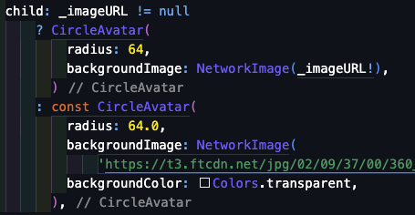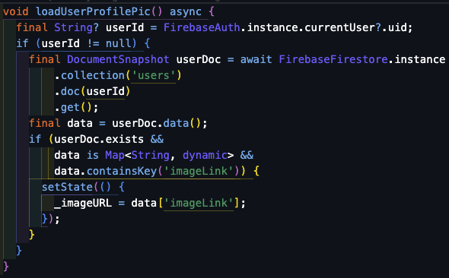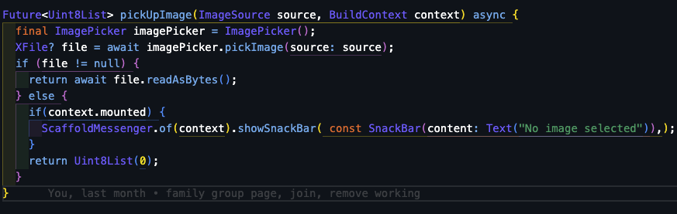

Figure 27 - Profile Load and Save image functions

The code snippets in Figure 27 outline the management of a user's profile picture within the application. Initially, the app fetches the current user's profile picture from Firestore, where it is stored and linked to their user ID. If an image link is found in the user's document, the UI updates to show this image within a circular frame. If no imageLink is found, a default image is displayed instead.

Users can update their profile picture by using the selectImage() function, which enables them to pick a new image from their device's gallery. Once an image is selected, it is converted into a Uint8List, a byte array format suitable for uploads. During this conversion process, a _isUploading flag is set to true, indicating that the upload is in progress. This helps manage the UI elements related to the upload, such as displaying a loading indicator to the user.

The saveProfilePic() function manages the actual upload, sending the byte array to a backend service for storage. If the upload is successful, the new image link is updated in the UI. If there's a failure or an error, the user is notified accordingly. Once the upload concludes, the _isUploading flag is reset to false, indicating that the upload process has finished.

On the user profile page, details such as the user's name, email, and phone number are displayed. Each of these details can be edited by pressing an edit button, which triggers the showEditDialog() method to update the specific information. This feature is supported by a StreamBuilder that continuously fetches the user profile data, ensuring that any changes made to the profile are immediately reflected on the page.

At the bottom of the screen, there is a button for users who wish to delete their account. Pressing this button activates the _deleteAccount() method, which completely erase the user's account from the system removing all the document saved in Firebase.

**/screen/memoryboard/components/body.dart**



Figure 28 - Capture photo and video or choose from the gallery method

When the Body() class is first initialised, the initState() method is called, which retrieves the family group ID to check if the user belongs to a family group. Based on this ID, the build method then constructs the UI layout. If no family group ID is available, it displays the JoinFamilyScreen. If there is a family group ID, it shows a screen titled "Family Memories," where media items are displayed. If there are no media items available, a message notifies the user that no media has been found. The media items are displayed in a grid format, with thumbnails for images and videos, which users can tap to view or play.

The fetchFamilyGroupId() method retrieves the family group ID from the database. Upon a successful fetch, it triggers _fetchAndUpdateMedia() to retrieve and display media items associated with the family group. The methods _pickMediaFromGallery(), _capturePhoto(), and _captureVideo() allow users to add new media to the memory board either from their gallery or by capturing new photos and videos directly with their device camera.

The _capturePhoto() and _captureVideo() methods make use of the ImagePicker to access the device camera. These methods call pickImage() or pickVideo() to capture a new photo or video. Once captured, the media is converted into a byte array Uint8List, which is the format required for uploading. This converted media is then uploaded using the same service that manages uploads from the gallery picker. A boolean (isVideo) parameter in these methods indicates if the media is a video, ensuring it is processed correctly.

**/screen/voicerecord/components/body.dart**

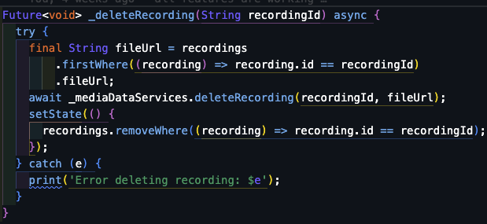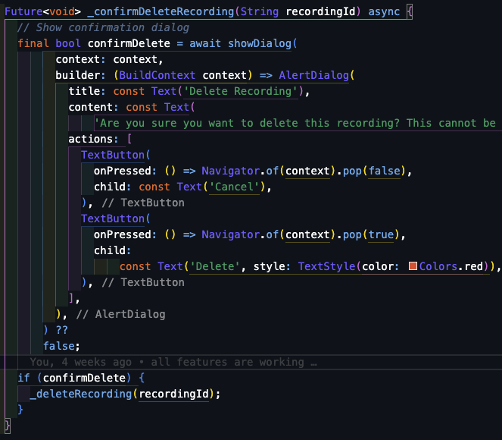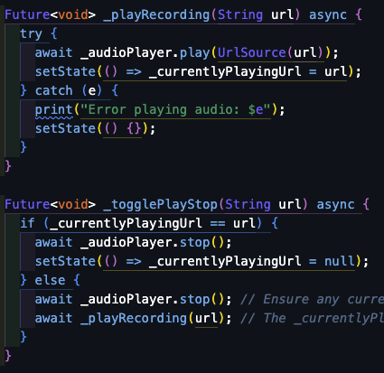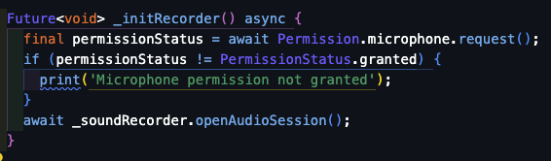

Figure 29 - Initialise voice record, delete record method and delete confirmation dialog methods

The code snippets from the Figure above showcase a set of methods for managing audio recordings on the storyteller page. The _initRecorder() method is tasked with setting up the audio recording environment, which involves requesting and checking for microphone permissions.

Audio playback is controlled through the _playRecording() method, which plays audio from a provided URL using an audio player library, and the _togglePlayStop() method acts as a switch to either play or stop the audio based on whether the audio is currently being played.

The recording list is managed and updated in the UI by the _initLoadRecordings and _loadRecordings() methods, which fetch recordings from the database related to the users family group. User interaction is facilitated by the _editTitleDialog method, which allows them to edit recording titles, and the _saveNewTitle() method, which ensures these changes are saved to the backend and updated in the UI.

The _confirmDeleteRecording() method displays a dialog asking the user for confirmation before deleting a recording to prevent accidental data loss. It returns a boolean indicating the user's decision and the _deleteRecording() method removes the recording from both the database and the UI keeping the display in sync with the backend data.

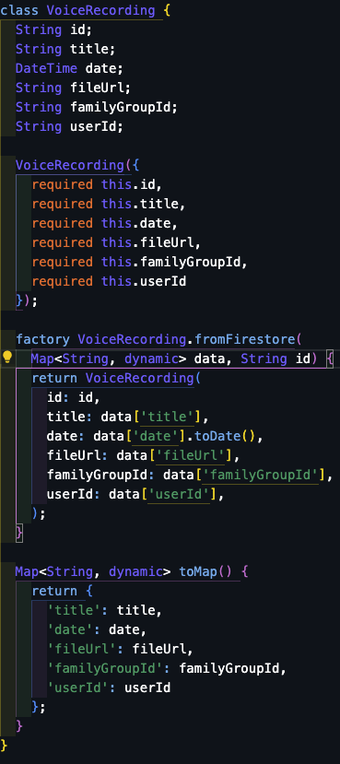

The VoiceRecording class is a data model for voice recordings within the app. It ensures each recording is well defined, supporting efficient storage, retrieval, and management. The factory constructor VoiceRecording.fromFirestore(), is designed to create a new instance from a map of data obtained from a Firestore database. This constructor efficiently extracts and converts the fields from the map, such as turning a Firestore Timestamp into a DateTime object, simplifying the integration of Firestore documents with the app's data structure.

Figure 30 - Voice recording model to retrieve data from Firebase

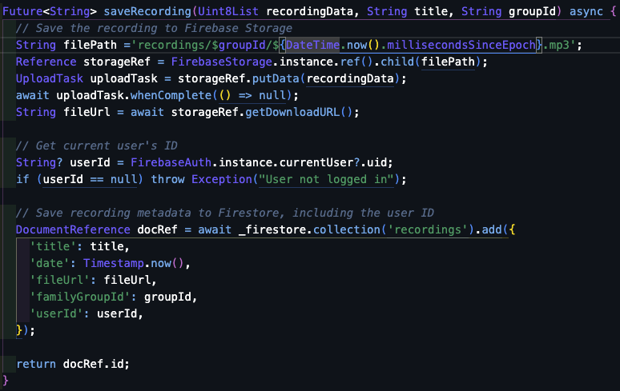

Figure 31 - Save voice recording method

The method illustrated in Figure 31 handles saving audio recordings by first storing the data in Firebase Storage and then retrieving the file URL and the current user's ID and using this information to save the recording metadata to the Firestore collection.

**/screen/task/components/body.dart**

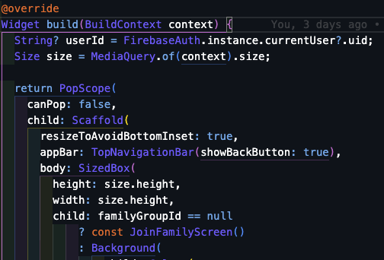

Figure 32 - Widget build

Figure 33 - StreamBuilder

In the Body class for the challenges feature, the application checks if the current user is the host and retrieves the family group ID. It uses a StreamBuilder to dynamically display the current points from user-specific document snapshots for all users.

The interface includes additional features specifically for hosts. They can access features like adding new tasks, setting up weekly rewards, and managing a scoreboard. The showAddTaskDialog() and showSetRewardDialog() functions allow hosts to create new tasks or adjust rewards, with options to reset points or remove existing rewards. Additionally, the showScoreboardDialog() function displays the points accumulated by each family member.

The code snippet in Figure 33 demonstrates how the StreamBuilder and ListView.builder are used to keep the task list synchronised. Users can mark tasks as complete or incomplete by tapping a checkbox, with each change being instantly updated in the backend database through _databaseService. If there is a failure in updating a task's status, users are promptly notified via a SnackBar. Additionally, the updatePointsAndDeleteCompletedTasks() method is crucial for updating user points based on task completion and for removing completed tasks from the list.

**/screen/location/body.dart**

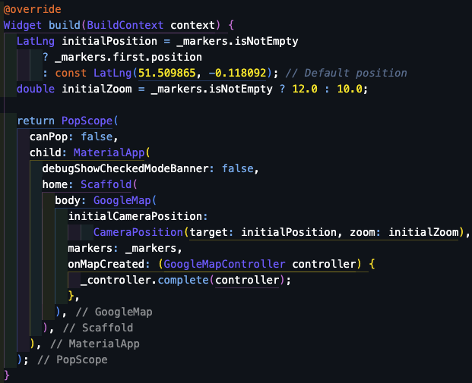

Figure 34 - Google Maps widget

Figure 34 shows the widget of a live map, keeping track of where family members are. It starts by asking for permission to use the device's location services. After permission is given, it keeps track of any location changes and shows each family member's spot using a special marker on Google Maps.

**Location_permission_request.dart**

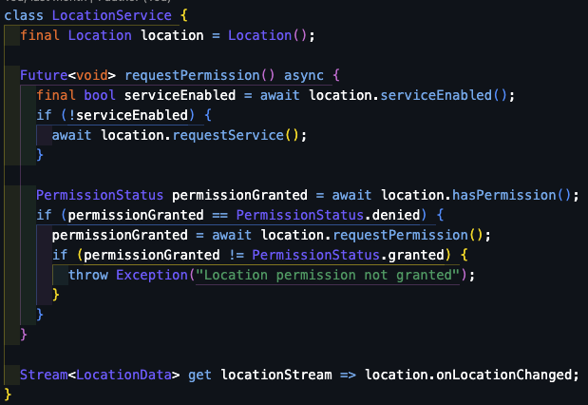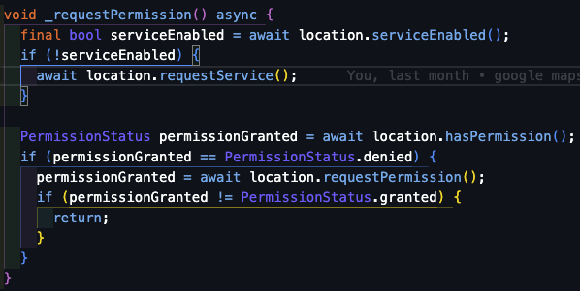

Figure 35- Request location services permission method

The requestPermission() method starts by checking if the location service is active on the device. If it's off, it prompts the user to turn it on using location.requestService(). If the user then denies location access for the "Hikiddo" app, the method throws an exception to let the user know that they do not have permission to use the location feature.

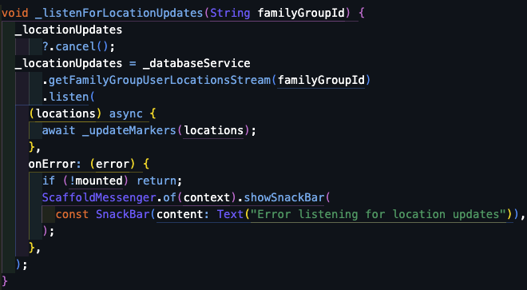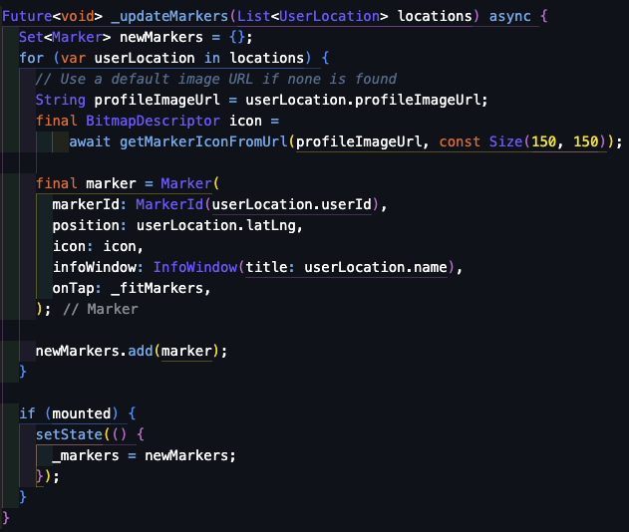

Figure 36 - Location and Markers update method

The _listenForLocationUpdates() method sets up a stream that continuously listens for real-time location updates from users. When it receives new location data, it triggers the _updateMarkers() method to update the markers on the map.

A new marker is generated for each user through the method _updateMarkers()

based on their location data. Each marker is customised with an icon created from the user's profile image URL. The function also adds a label that displays the user's name on each marker. Once the new markers are ready, the function updates the app's state to reflect these changes on the user interface.



This code snippet illustrates a method that takes a user profile image from a URL and turns it into a customised map marker. The image byte array is used to create a BitmapDescriptor with the fromBytes(uint8List) method, which is the specific format needed for Google Maps to display personalised marker icons.

The method for making these custom map markers was modified from a solution found on StackOverflow.

Figure 37 - Marker icon method

7. Testing

## 7.1 Test coverage

In the development of any software, it is crucial that we ensure that an application aligns with its intended requirements. Two key testing methodologies used in this process are Black Box Testing and White Box Testing, each offering unique advantages. Exploring both methods provides insight into how they contribute to confirming that the software performs as expected and helps pinpoint potential improvements.

Black Box Testing:

Black Box Testing checks the software from the outside without looking into the source code. Using this methodology, we can see how the application responds to inputs, focusing on ensuring the application works well, is easy to use, and performs efficiently from a user's perspective.

Table 2 – Black box testing

|  |  |  |
| --- | --- | --- |
| Pages | Test Case | Result |
| Welcome | Clicking the login or sign-up button will direct the user to the appropriate page. | Pass |
| Sign-up | When the user enters special characters or numbers in the name field, the system displays a validation error message. | Pass |
| If a user enters an email in an incorrect format, the system will show a validation error message. | Pass |
| The user must create a password that follows these rules:   1. at least one uppercase letter 2. at least six characters long 3. at least one number.   If the password does not meet these requirements, the system will display a validation error message. | Pass |
| Users have the option to view their password before completing the sign-up. | Pass |
| Users can sign up using other options such as the ones displayed in the app, including Facebook, Google, and Apple. | Fail |
| Users can click on the "sign in" link to navigate directly to the login page. | Pass |
| By clicking the sign-up button, users will be redirected to the next step. | Pass |
| Users need to confirm their email to successfully create their account. | Pass |
| New users have the option to join an existing family group or create a new one. | Pass |
| When a user joins an existing family group, a "request to join as been sent" message is displayed. | Pass |
| Login | User can enter their credentials | Pass |
| When the user clicks on the login button, they are redirected to the home page. | Pass |
| If the credentials entered do not match, a validation error message will be displayed. | Pass |
| When users click on the "Forgot your password" link, they are redirected to the forgot password page. | Pass |
| The "Sign up here" link redirects users to the sign-up page. | Pass |
| Home Page | All buttons on the page are functioning correctly. | Pass |
| Sidebar Menu | Everything works and the links are redirecting accordingly. | Pass |
| On the contact us page, the support link redirects the user to their mail app. | Pass |
| Map view | The map displays the current location of family members. | Pass |
| If a user has not uploaded a profile picture, a default one will be displayed. | Pass |
| Clicking on the profile picture on the map will zoom in on the map. (this does not work well on the mobile simulator) | Pass |
| Profile | Users can change their name, email, and phone number. | Pass |
| Name, email and phone number have input validation | Pass |
| Changing the email will result in a change to the user's login credentials. | Fail |
| Clicking on the "Delete My Account" button, the user's account will be deleted. | Pass |
| A confirmation message is displayed before deleting the account. | Fail |
| Users have the option to upload a profile picture. If no image is upload, a default one is displayed. | Pass |
| Memories | Users can view photos and videos uploaded by all members of the family group. | Pass |
| Users can upload photos or videos from their device gallery. | Pass |
| Users can capture photos or videos using their device camera | Pass |
| While the upload of these files is being stored, users will see a message. | Pass |
| If the upload of the files fails to be saved in the database storage, an error message will be displayed. | Pass |
| Storyteller | Users can record a voice message. | Pass |
| Users can listen to the voice messages created by other members of the family group. | Pass |
| The host user or the user who created the voice recording can delete or change the title of the recording. | Pass |
| Challenges | Host user can create new task | Pass |
| The host user can add a reward and its description. | Pass |
| Host user can view the score board | Pass |
| Host user can reset points | Pass |
| Users can complete tasks by ticking the checkbox and clicking on the update button. This action will automatically mark the task as complete and update their points. | Pass |
| Users can see their points. | Pass |
| Family group | Users can see information about the group such as Name of the family group and list of members. | Pass |
| When a user clicks on the "Leave the Group" button, they are removed and lose access to the family group-related features. | Pass |
| Users can request to join a new family group. | Pass |
| If the host user clicks on the "Delete Group" button, the group will be deleted, and all information related to that group will be removed. | Pass |
| If the host user clicks on the "Manage Requests" button, they can accept or decline new member requests. | Pass |
| If the host user clicks on the "Remove" button next to a member's name, that user will be removed from the group. | Pass |

White Box Testing was essential for ensuring the Hikkido mobile app is secure and handles data effectively. This testing method explores the app’s coding, examining how it executes tasks and manages data flow. By testing the functions created, I have ensured the app securely accesses data relevant only to a user's family group, preventing issues such as accidental access to other family groups' data or app crashing due to failed data retrievals.

In conclusion, combining Black Box and White Box Testing forms a quality assurance strategy for the Hikkido app. Black Box Testing evaluates the app from a user's perspective, focusing on the interface and how users interact with the app. On the other hand, White Box Testing examines the inner workings and code structure, ensuring the app handles data securely and reliably. Using these testing methods together ensures the app meets expectations and adheres to high standards for coding and security. This dual approach boosts the app’s quality, stability, and reliability, increasing user satisfaction and trust in the Hikkido platform.

## 7.2 Test methodology

For the Hikiddo app, the test methodology adopted in this phase was crucial for assuring the app's quality and functionality. I have set a detailed testing process that included feedback from both expert and non-expert users.

This approach allowed to identify and solve potential issues by incorporating insights from users with different levels of expertise. The strategy aims not only to improve accuracy but also to significantly enhance user experience and security.

The initial phase of testing the application involved using a mobile emulator to confirm that the design worked well on both Android and iOS platforms. During this stage, critical features such as login and authentication with Firebase were tested to see how the system responded to incorrect inputs, with any issues being documented and addressed.

As development progressed, it became crucial to test the application on a physical device, especially to assess location features and multi-user interactions. Running the application on both an emulator and physical hardware allowed for a comparison of performance and functionality in different environments. Additionally, deploying the application on a mobile device facilitated the collection of feedback from a range of users, which helped to significantly enhance the overall quality of the application.

Feedback played a vital role in the testing process. Insights were gathered from various sources, such as friends and colleagues, which helped identify weaknesses in the application's functionality. This feedback led to improvements in both functionality and design, enhancing accessibility for users of all ages.

Non-expert users played a crucial role in evaluating the application’s usability, ease of use, and overall user experience. Their feedback was crucial in identifying usability challenges and offering insights that improved the application's intuitiveness and ease of use.

By integrating feedback from both expert and non-expert users, the testing methodology embraced a comprehensive approach to identify and resolve issues. This strategy was crafted to improve the overall quality and performance of the application.

# 8. Conclusions and reflections

Developing the "HiKiddo" application has been a tremendously rewarding experience that deepened my understanding of Full-stack mobile development. This project introduced me to the Flutter framework and the Dart programming language, expanding my technical expertise significantly. I also gained proficiency in using Firebase services like Firebase Database for secure data storage, Firebase Authentication for managing user logins, and Firebase Storage for media uploads. I have also learned how to integrate Google APIs, which added another layer of technical expertise to my growing skill set. Additionally, managing my code through GitHub enhanced my skills in software development and version control.

The requirement-gathering phase was critical to the project's success. In this phase, I focused on researching and defining the project's goals. Researching the problem proposed and evaluating similar apps were crucial steps. I have tested existing family-oriented apps, which established the foundation for this project and provided valuable insights for its development. This process allowed me to gather ideas and refine the development approach, ensuring an understanding of user needs and effectively shaping the project aims and objectives. The application development followed an Agile methodology, allowing for flexibility and iterative improvements based on ongoing testing and feedback. While this approach was effective in managing the project dynamically, the challenge was ensuring consistent documentation and maintaining a clear focus on the project timeline and scope. The testing phase was critical in identifying bugs and usability issues. However, the testing could have been enhanced using unit tests and potentially conducting more tests to see how the app performs in real-world conditions.

Evaluating the initial objectives with the current final product, I can confidently say that the “Hikiddo” application meets its primary goal, which was to use technology to strengthen family bonds, concentrate on personal connections, offer a platform for parents and children to share moments and messages, thereby enhancing their relationships in today's digital and fast-paced world. However, I believe there is room for improvement by incorporating additional interactive and educational features to enhance user engagement.

One area of focus is the memory board feature. I plan to enhance it by arranging photos and videos in chronological order and adding a comment section where users can share their thoughts and interactions. This update will not only simplify the navigation of memories but also foster more social engagement among family members.

Furthermore, I plan to enhance the challenges and rewards feature to boost family interaction. Introducing badges or medals that users can earn through completing tasks will promote both competition and engagement. Additionally, allowing users to upload photos to demonstrate task completion, with these photos then reviewed by the host user for validation, will make the feature more engaging and credible. This verification step cannot only increase motivation but also add to the appeal of participating in challenges within the household.

The Storyteller feature, while functional, currently has limited capabilities, allowing users only to record their voices and share them within the family group. To enhance this feature and make it more engaging, I aim to create a dedicated space where parents can record bedtime stories or meaningful messages for their children. Additionally, integrating a speech-to-text feature would enable children not just to listen but also to read along with their loved ones' voices. This feature could promote reading skills, particularly among younger children. These enhancements would transform Storyteller into a more interactive and educational tool within the app.

The track location feature currently gives parents peace of mind by allowing them to always know where their loved ones are. To enhance this feature, I plan to make a few small but impactful additions. One key update is giving parents the option to see their children's location history for the last few hours, which provides a more detailed understanding of their movements. Additionally, I would like to add a safety button that family members can press to quickly contact emergency services. This feature will add an extra layer of security, ensuring that help is accessible in case of an emergency.

In conclusion, reflecting on the project objectives and the final product, I believe that "HiKiddo" has successfully achieved its primary goal of using technology to strengthen family ties and establish a valuable platform for ongoing learning and development. By maintaining a focus on user-centred design for all age groups, "HiKiddo" can continue to evolve and more effectively support modern families. Moving forward, it will continue to enhance family connections and support children’s development, evolving to meet the demands of our increasingly digital world.

# 9. References

1. Academic Journal Article:

Mao, M., Zang, L., & Zhang, H. (2020). The Effects of Parental Absence on Children Development: Evidence from Left=Behind Children in China. International Journal of Environmental Research and Public Health.

<https://www.ncbi.nlm.nih.gov/pmc/articles/PMC7559575/#:~:text=Left%2Dbehind%20children%20have%20a,negative%20effects%20on%20children's%20development>.

1. Employer News (2021, April 29)

Separation Anxiety: 46% of Parents are Worried about Missing Key Moments in Their Child’s Development upon Returning to Work

<https://employernews.co.uk/news/separation-anxiety-46-of-parents-are-worried-about-missing-key-moments-in-their-childs-development-upon-returning-to-work/>

1. Badria Elbitar (2023, July 2)

The Impact of Busy Working Parents on Children

<https://www.linkedin.com/pulse/impact-busy-working-parents-children-badria-elbitar/>

1. Alisa Jaffe Holleron (2017, July 28)

Co-Parenting and the Pain of Spending Time Away from Children

<https://alisajaffeholleron.com/blog-post/co-parenting-pain-spending-time-way-from-children/>

1. Brandon T McDaniel, Jenny S Radesky (2017, May 10)

Technoference: Parent Distraction With Technology and Associations With Child Behavior Problems

<https://pubmed.ncbi.nlm.nih.gov/28493400/>

1. McDermott Method (2019, July 10)

When You are Too Busy for Your Kids

<https://www.macdermottmethod.com/blog/when-you-are-too-busy-for-your-kids>

1. Remento

<https://www.remento.co/#HIW>

1. Life360

<https://www.life360.com/uk/>

1. FamilyAlbum

<https://family-album.com/en-gb>

1. Daniela Montano (2024/ January 19)

Why use Flutter: Pros and Cons of Flutter App Development

<https://waverleysoftware.com/blog/why-use-flutter-pros-and-cons/>

1. Amol Pawar (2024, February 15)

React Native and Node.js: The Secret Weapon for Building Scalable, High-Performance Mobile Apps

<https://medium.com/@amoljp19/react-native-and-node-js-the-secret-weapon-for-building-scalable-high-performance-mobile-apps-95f33f01a83f#:~:text=React%20Native's%20declarative%20programming%20paradigm,were%20built%20using%20native%20tools>.

1. Hitesh Agarwal (203, June 21)

Advantages and Disadvantages of Using React Native

<https://techexactly.com/blogs/advantages-and-disadvantages-of-using-react-native>

1. Umut Can Aldirmaz ( 2023, October 2)

What is Kotlin? What are the Advantages and Disadvantages? Where Is It Used? What should be Java Kotlin Preference?

<https://medium.com/@ucan.aldirmaz/what-is-kotlin-life-with-kotlin-series-1-93e21038dde5>

1. Altexsoft (2021, September 13)

The Good and the Bad of Swift Programming Language

<https://www.altexsoft.com/blog/the-good-and-the-bad-of-swift-programming-language/>

1. Sparkout Tech Marketing (2024, April 15)

Advantages and disadvantages of the Swift language

<https://medium.com/@sparkouttechmarketing/advantages-and-disadvantages-of-the-swift-language-db95d4b9bd84>

1. Daniel Raymond

MySQL: 10 Cons & Disadvantages with 5 Alternatives

<https://projectmanagers.net/mysql-10-cons-disadvantages-with-5-alternatives/>

1. Suman (2024, April 19)

What is MySQL?

<https://intellipaat.com/blog/what-is-mysql/>

1. Sakshi Sureka (2022, October 23)

Should Professionals Use Firebase? Pros and Cons

<https://pangea.ai/blog/domains/should-professionals-use-firebase-pros-and-cons>

1. Andrea Bizzotto (2023, April 28)

Firebase Pros and Cons (For Flutter app development)

<https://codewithandrea.com/videos/firebase-pros-cons-flutter/>

1. Kyle chin (2023, August 21)

Cybersecurity and Social Responsibility: Ethical Considerations

<https://www.upguard.com/blog/cybersecurity-ethics>

1. Alhazmi, A. and Gamagedara Arachchilage (2021 May 1)

I’m all ears! Listening to software developers on putting GDPR principles into software development practice

<https://link.springer.com/article/10.1007/s00779-021-01544-1#author->

1. Tan, T.C (2021, September 8)

Guide to Lite Agile: The Lightest Framework for Individual Transformation

<https://iamthye.medium.com/guide-to-lite-agile-the-lightest-framework-for-individual-transformation-5b361afdebe2>

1. True Coders (2023, April 15)

How to save image using flutter and firebase | firebase_storage | upload using putFile() | Part 2

<https://www.youtube.com/watch?v=5kjjkIdwwN8>

1. CodingWizard (2023, September 8)

Voice recorder app in Flutter | Speed code #flutter

<https://www.youtube.com/watch?v=fbeisx6QacI>

1. Kavit zenwraight (2022, February 16)

Flutter Tutorial: Image Picker from Camera & Gallery

<https://medium.com/unitechie/flutter-tutorial-image-picker-from-camera-gallery-c27af5490b74>

# Appendix I

*Provide additional material, if appropriate, in separate appendices.*

*Use one Appendix to provide a link to an on-line video demo of the project.*

*Do not include the entire code in print as an appendix.*